Name

Mathematics Stage 4
Comparing Fractions

Book 1 | Compare Fractions  Round Decimals | Version: 260409  Feedback:  https://MrDingMaths.com
Contents
Syllabus Content 2
Highest Common Factor 3
Lowest Common Multiple 6
Relating HCF and LCM 9
Producing Equivalent Fractions using Diagrams 16
Producing Equivalent Fractions using the Rule 21
Simplifying Fractions 27
Comparing Fractions: Same Denominator/Same Numerator 32
Comparing Fractions: Related Denominators 35
Comparing Fractions: Unrelated Denominators 39

Syllabus Content
MA4-FRC-C-01 represents and operates with fractions, decimals and percentages to solve problems
Compare fractions using equivalence
- Determine the highest common factor (HCF) of 2 whole numbers
- Examine methods of generating equivalent fractions
- Simplify fractions by using methods, including determining the HCF of the numerator and denominator or repeated simplification using common factors
- Create fractions with the same denominator to compare their sizes
- Compare and order fractions with different denominators

Highest Common Factor

- Highest Common Factor
The highest common factor (HCF) is the largest factor shared by two or more numbers.

To find the HCF: or
- List all the factors of both numbers.  - Identify the largest shared factor. | Think of the largest number that can divide evenly into each the numbers.

- Example Determine the highest common factor of two numbers
Determine the HCF of 36 and 48  1. Factors of 36: 1, 2, 3, 4, 6, 9, 12, 18, 36  Factors of 48: 1, 2, 3, 4, 6, 8, 12, 16, 24, 48  2. The highest common factor is 12. | In mathematics, “common” means something two or more quantities ………………  The HCF is the largest number that you can …………… two numbers by.

- Guided Practice
- 6 and 15  Factors of 6: 1, 2, 3, 6  Factors of 15: 1, 3, 5, 15  The HCF is …………… | - 15 and 12  Factors of 15: …………………………  Factors of 12: …………………………  The HCF is ……………
- 16 and 20 | - 16 and 32

- Key Ideas
- A factor is a number that …………………… into another number with no remainder.
- The HCF is the ………………… factor that two numbers …………………

Foundation
- Fill in the gaps to complete the set of factors for each of the following numbers.
  - 18 1, 2, __, 6, 9, __
1, 2, 3, 6, 9, 18
  - 25 1, __, 25
1, 5, 25
  - 72 __, 2, 3, __, __, 8, __, __, 18, __, 36, 72
1, 2, 3, 4, 6, 8, 9, 12, 18, 24, 36, 72
  - 120 1, 2, __, __, __, 6, __, 10, __, __, 20, __, 30, __, 60, __
1, 2, 3, 4, 5, 6, 8, 10, 12, 15, 20, 24, 30, 40, 60, 120
- List all the factors of these numbers.
- 10  1, 2, 5, 10 | - 15  1, 3, 5, 15 | - 12  1, 2, 3, 4, 6, 12
- 20  1, 2, 4, 5, 10, 20 | - 40  1, 2, 4, 5, 8, 10, 20, 40 | - 24  1, 2, 3, 4, 6, 8, 12, 24
- Fill in the missing numbers to find the HCF of 18 and 30:
Factors of 18 are 1, ____, 3, ____, ____ and 18.
1, 2, 3, 6, 9 and 18
Factors of 30 are 1, ____, ____, 5, ____, 10, ____ and 30.
1, 2, 3, 5, 6, 10, 15 and 30
Therefore, the HCF of 18 and 30 is _____.
6
- Find the Highest Common Factor of the following pairs of numbers.
a 8 and 14  Factors of 8:  Factors of 14:  2 | b 10 and 15  Factors of 10:  Factors of 15:  5
c 16 and 20  4 | d 15 and 60  15
e 12 and 42  6 | f 48 and 72  24
e 50 and 150  50 | f 28 and 36  4

  - List the factors of 16
1, 2, 4, 8, 16
  - List the factors of 32
1, 2, 4, 8, 16, 32
  - List the common factors of 16 and 32
1, 2, 4, 8, 16
  - What is the highest common factor of 16 and 32?
16
  - What do you notice? Why does this happen?

The HCF equals the smaller number. This happens because 16 is a factor of 32

  - List the factors of 7
1, 7
  - List the factors of 9
1, 9
  - List the common factors of 7 and 9
1
  - What is the highest common factor of 7 and 9?
1
  - What do you notice? Why does this happen?
The only common factor is 1. This happens because 7 and 9 share no other factors; they are ‘coprime’
- Find the Highest Common Factor of the following pairs of numbers.
- 12 and 1  1 | - 12 and 9  3 | - 12 and 17  1
- 12 and 2  2 | - 12 and 10  2 | - 12 and 18  6
- 12 and 3  3 | - 12 and 11  1 | - 12 and 19  1
- 12 and 4  4 | - 12 and 12  12 | - 12 and 20  4
- 12 and 5  1 | - 12 and 13  1 | - 12 and 30  6
- 12 and 6  6 | - 12 and 14  2 | - 12 and 40  4
- 12 and 7  1 | - 12 and 15  3 | - 12 and 50  2
- 12 and 8  4 | - 12 and 16  4 | - 12 and 60  12

Lowest Common Multiple

- Lowest Common Multiple
The lowest common multiple (LCM) is the smallest multiple shared by two or more numbers.

To find the LCM: or
- List some multiples of both numbers.  - Find the smallest shared multiple. | Multiply the two numbers, then divide by the HCF

- Example Determine the highest common factor of two numbers
Determine the LCM of 6 and 8  1. Multiples of 6: 6, 12, 18, 24, 30, …  Multiples of 8: 8, 16, 24, 32, 40, …  2. The lowest common multiple is 24 | We only write a few multiples because there are an ……………… number of multiples.  We only need to write a few to find the LCM.

- Guided Practice
- Determine the LCM of 6 and 9.
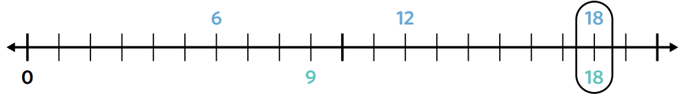

Multiples of 6: 6, 12, 18
Multiples of 9: 9, 18 The LCM is ………
- Determine the LCM of 2 and 5.
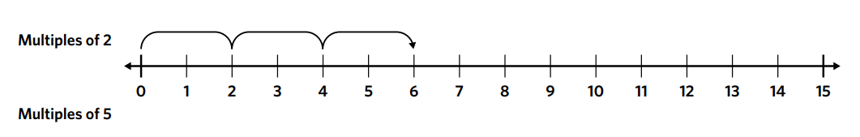

Multiples of 2: ………………………
Multiples of 5: ……………………… The LCM is ………

- Determine the LCM of 8 and 12.

Multiples of 8: ………………………
Multiples of 12: ……………………… The LCM is ………

- Key Ideas
- A multiple is the …………………… of a number and another number.
- The LCM is the ………………… multiple that two numbers …………………

Foundation
- Use the number lines to find the
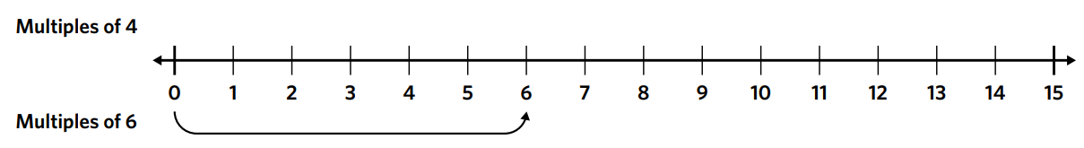
  - LCM of 4 and 6

12
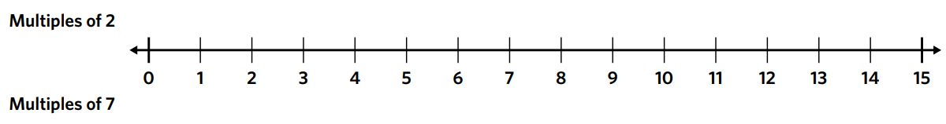
  - LCM of 2 and 7

14
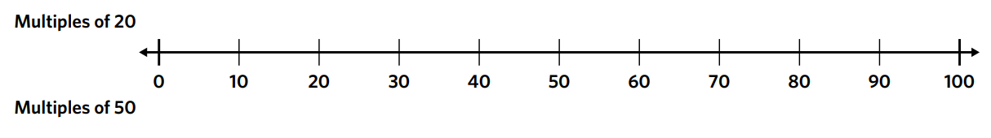
  - LCM of 20 and 50

100
- Fill in the missing numbers to find the LCM of 9 and 15:
Multiples of 9 are ____, ____, ____, ____, ____,
9, 18, 27, 36, 45
Multiples of 15 are ____, ____, ____,
15, 30, 45
Therefore, the LCM of 9 and 15 is ____.
45
- Find the Lowest Common Multiple of these pairs of numbers:
a 4 and 9  Multiples of 4:  Multiples of 9:  36 | b 3 and 7  Multiples of 3:  Multiples of 7:  21
c 12 and 5  60 | d 10 and 11  110
e 6 and 9  18 | f 5 and 10  10
e 15 and 20  60 | f 9 and 12  36

  - List the first ten multiples of 12
12, 24, 36, 48, 60, 72, 84, 96, 108, 120
  - List the first ten multiples of 6
6, 12, 18, 24, 30, 36, 42, 48, 54, 60
  - Identify the common multiples of 12 and 6 from your lists.
12, 24, 36, 48, 60
  - What is the lowest common multiple of 12 and 6?
12
  - What do you notice? Why does this happen?

The LCM equals 12, one of the original numbers. When one number is a multiple of the other, the LCM is the larger number.

  - List the first ten multiples of 7
7, 14, 21, 28, 35, 42, 49, 56, 63, 70
  - List the first ten multiples of 9
9, 18, 27, 36, 45, 54, 63, 72, 81, 90
  - Identify the common multiples of 7 and 9 from your lists.
63
  - What is the lowest common multiple of 7 and 9?
63
  - What do you notice? Why does this happen?

The LCM equals 7 × 9 = 63. Since 7 and 9 share no common factors (they are coprime), the LCM is their product.
- Find the Lowest Common Multiple of the following pairs of numbers.
- 12 and 1  12 | - 12 and 9  36 | - 12 and 17  204
- 12 and 2  12 | - 12 and 10  60 | - 12 and 18  36
- 12 and 3  12 | - 12 and 11  132 | - 12 and 19  228
- 12 and 4  12 | - 12 and 12  12 | - 12 and 20  60
- 12 and 5  60 | - 12 and 13  156 | - 12 and 30  60
- 12 and 6  12 | - 12 and 14  84 | - 12 and 40  120
- 12 and 7  84 | - 12 and 15  60 | - 12 and 50  300
- 12 and 8  24 | - 12 and 16  48 | - 12 and 60  60

Relating HCF and LCM

Foundation
- Given $7×8=56$
Which of these statements are true? Circle 2 answers.
- 7 is a multiple of 56 | - 8 is a factor of 56 | - 7 is a factor of 56
b, c
- Given $5×4=20$
Which of these statements are true? Circle 2 answers.
- 20 is a multiple of 4 | - 5 is a multiple of 20 | - 5 is a factor of 20
a, c
- Given $6×7=42$
Which of these statements are true? Circle 2 answers.
- 42 is a multiple of 7 | - 6 is a factor of 42 | - 42 is a factor of 7
a, b
- Given $9×2=18$
Which of these statements are true? Circle 2 answers.
- 9 is a factor of 18 | - 18 is a multiple of 2 | - 18 is a factor of 9
a, b
- Given $8×5=40$
Which of these statements are true? Circle 2 answers.
- 8 is a factor of 40 | - 5 is a factor of 40 | - 5 is a multiple of 8
a, b
- For each of the following numbers, circle whether they are factors (F), multiples (M) or neither (N) of the number 60.
a 120 F M N  M | b 14 F M N  N | c 15 F M N  F
d 40 F M N  F | e 6 F M N  F | f 5 F M N  F
g 240 F M N  M | h 2 F M N  F | i 22 F M N  N
j 600 F M N  M | k 70 F M N  N | l 1 F M N  F

- Determine the lowest common multiple of each set of numbers.
- 5 and 8  40 | - 6 and 7  42 | - 4 and 3  12
- 2 and 11  22 | - 11 and 4  44 | - 9 and 4  36
What do you notice about your answers? Why does this happen?

When two numbers share no common factors, the LCM is their product.
- Work out the lowest common multiple for each set of numbers.
- 6 and 12  12 | - 27 and 3  27 | - 15 and 5  15
- 10 and 30  30 | - 24 and 8  24 | - 51 and 17  51
What do you notice about your answers? Why does this happen?

When one number is a multiple of the other, the LCM is the larger number.
- Identify the highest common factor of each pair of numbers.
3 | 5 | 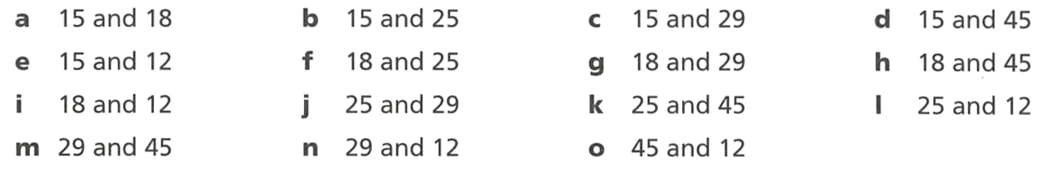  1 | 15
3 | 1 | 1 | 9
6 | 1 | 5 | 1
1 | 1 | 3

- A shortcut for finding the LCM is to find the product of the two numbers, then divide the product by the HCF.
Example: Find the lowest common multiple of 6 and 10:
Find product: $6×10=60$
Find HCF: HCF of 6 and 10 is 2.
Divide by HCF: $60÷2=30$ Therefore, the LCM of 6 and 10 is 30.
Find the HCF of each of these numbers, then use it to calculate the LCM.
- 14 and 8  56 | - 12 and 9  36
- 15 and 20  60 | - 14 and 21  42
- 25 and 15  75 | - 18 and 24  72
- 24 and 36  72 | - 30 and 45  90
- 42 and 56  168 | - 48 and 64  192
- 36 and 120  360 | - 45 and 75  225

Development
- Identify the highest common factor of each pair of numbers.
3 | 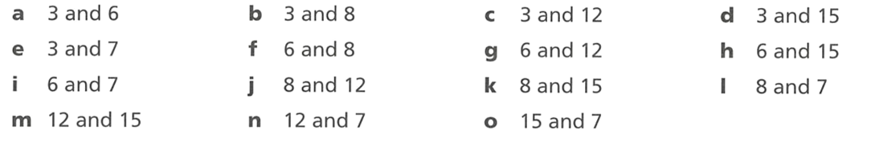  1 | 3 | 3
1 | 2 | 6 | 3
1 | 4 | 1 | 1
3 | 1 | 1

- Find the HCF and LCM of these pairs of numbers.
  - 5 and 10 HCF: ………… LCM: …………
5, 10
  - 10 and 5 HCF: ………… LCM: …………
5, 10
  - 20 and 5 HCF: ………… LCM: …………
5, 20
  - 20 and 10 HCF: ………… LCM: …………
10, 20
  - 20 and 30 HCF: ………… LCM: …………
10, 60
  - 10 and 30 HCF: ………… LCM: …………
10, 30
  - 5 and 30 HCF: ………… LCM: …………
5, 30
  - 6 and 30 HCF: ………… LCM: …………
6, 30
  - 4 and 30 HCF: ………… LCM: …………
2, 60
  - 3 and 30 HCF: ………… LCM: …………
3, 30
  - 7 and 30 HCF: ………… LCM: …………
1, 210
  - 12 and 15 HCF: ………… LCM: …………
33, 60
  - 20 and 25 HCF: ………… LCM: …………
5, 100
  - 18 and 24 HCF: ………… LCM: …………
6, 72
  - 11 and 21 HCF: ………… LCM: …………
1, 231
  - 8 and 40 HCF: ………… LCM: …………
8, 40
  - 36 and 48 HCF: ………… LCM: …………
12, 144

- Two numbers are even. What must be one of their common factors?
2
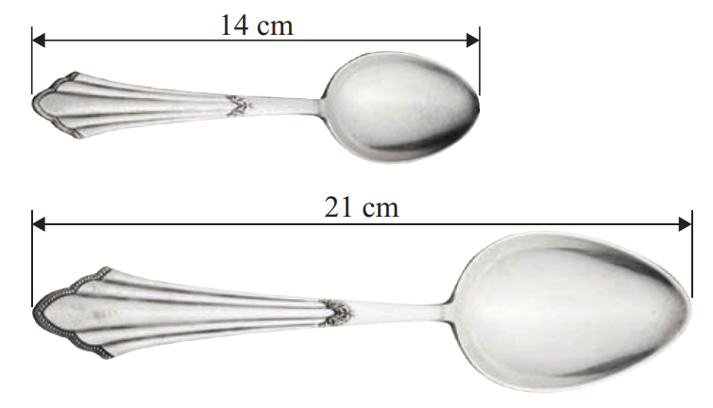
- A line of teaspoons (14 cm) is next to a line of spoons (21 cm).

  - What is the smallest number of each spoon that would make the lines equal in length?
3 teaspoons, 2 spoons
  - How long would that line be?
42 cm
  - The answer to part b is called the ……… of 14 and 21
LCM

- Wendy is a florist who is making up small bunches of roses for sale.
She has 36 red roses, 42 pink roses and 30 cream roses.
Each bunch contains only one colour.
Each bunch must contain the same number of roses. Wendy wants to use all the roses.
  - What is the largest number of roses Wendy can put in each bunch?
6
  - The answer to part a is called the ……… of 36, 42 and 30.
HCF
  - How many bunches of each colour can she make?
6 red, 7 pink, 5 cream

- The highest common factor of two numbers is 5. The lowest common multiple is 150.
What could the two numbers be? Is there more than one answer?
Need pairs where HCF=5 and LCM=150.
LCM = product/HCF → product = 750.
multiples of 5 with product 750 and HCF 5: (5,150), (25,30). Yes, more than one answer.

Mastery
In each of the following questions, determine whether to use the HCF or LCM to solve the question.
- A dentist advises a patient to have a scale every 4 months and a polish every 6 months.
If they have a scale and polish today, how long will they wait before they can have both during the same appointment?

12 months
- Sophie checks her bike for repairs every 9 days and Susan check hers every 12 days.
If they both check their bikes today, after how many days do they next both check their bike again?

36 days
- A carpenter got given some free wooden planks. Some are 12m long and some are 18m long. She wants to cut them up so that she has equal size planks to make using them easier.
What size planks should she cut them into to avoid wasting any wood?

6 m planks
- A bus company has 21-seater and 35-seater buses.
What is the smallest group which will fit exactly onto a whole number of buses of either type?

105 seats
- Year 7 has 48 students. Year 8 has 90 students.
Each year group must be separately divided into football teams so that all teams are the same size, and there are no people left over. What’s the largest team size?

6
- Tom and Claire both like do short exercise that involve small breaks.
Tom does a short burst of exercise every 2 minutes, and Claire does hers every 3 minutes.
If they start doing their exercise at 9:00 am, when do they both do their exercises again?

6 minutes, 9:06 am
- Trains leave Central to Parramatta every 15 minutes and to Chatswood every 21 minutes.
A train to Parramatta and a train to Chatswood both leave Central at 11 am.
What is the next time a train to Parramatta and a train to Chatswood will leave at the same time?

After 105 minutes
12:45 pm
- The 90A bus and the 95B bus both stop at the bus station at 12:00.
90A stops there every 20 minutes and 95B stops there every 8 minutes.
When do they both stop there again?

40 minutes; 12:40
- Train A and Train B stops at Swindon as 10:30.
Train A stops every 12 minutes and Train B stops every 14 minutes.
When do they both stop at Swindon again?

84 minutes. 10:30 + 84 minutes = 11:54 am
- There are two loaf cakes. One is 35cm long and one is 27cm long.
They want to cut the cake up and sell the slices, but all the slices must be equal.
What is the largest slices that they can cut them into?

1 cm
- Umar and Aiden are both keen runners.
Umar takes 5 minutes to jog around a running track and Aiden takes 4 minutes.
They start at the same time and run until they both cross the finish line at the same time.
  - How long do they run for?
20 minutes
  - How many laps did Aiden run?
5 laps
  - How many laps did Umar run?
4 laps
- James and Harry had the same amount of money.
James spent all his money on books that cost $6 and Harry spent all his on books costing $8.
If they both had more than $50 but less than $90, how many books did they each buy?

Need LCM between 50 and 90: so 72.
James bought 72÷6=12 books; Harry bought 72÷8=9 books.

Producing Equivalent Fractions using Diagrams

- Equivalent Fractions
Equivalent fractions represent the same value.
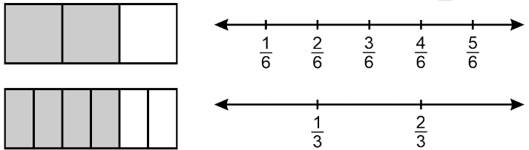
They represent the same part of the whole and the same distance on a number line.

$$\frac{2}{3}=\frac{4}{6}$$

- Example Produce equivalent fractions
$$\frac{1}{2}=\frac{2}{4}=\frac{3}{6}$$  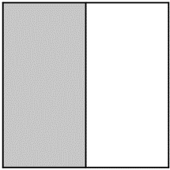  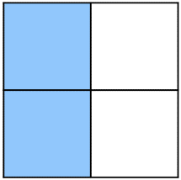  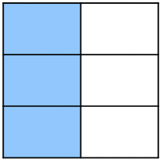 | We produce equivalent fractions by splitting the same ………… into more parts.

- Guided Practice
- $\frac{2}{5} = \frac{ }{10} = \frac{ }{15}$  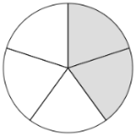  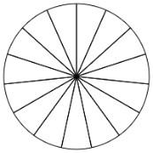  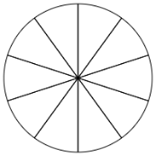 | - $\frac{ }{ } = \frac{2}{8} = \frac{ }{ }$  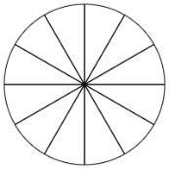  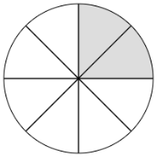  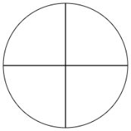
- $\frac{ }{8}=\frac{9}{12}$  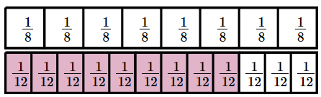 | - $\frac{1}{4}=\frac{ }{ }$  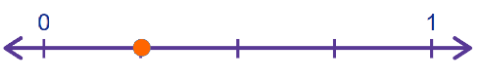  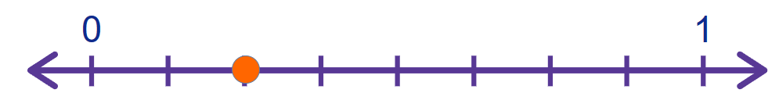
- $\frac{2}{5}=\frac{ }{ }$  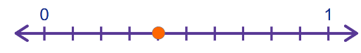  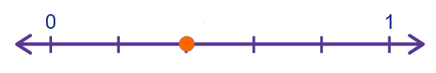 | - $\frac{2}{3}=\frac{ }{ }$  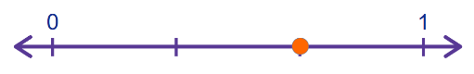  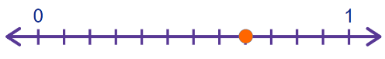

Foundation
- Fill in the missing numbers.
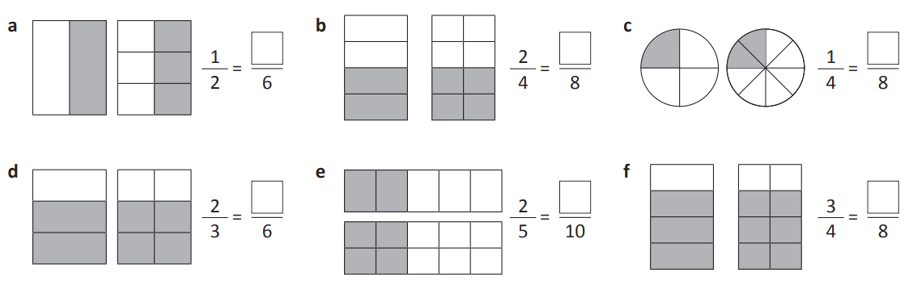  3 | 4 | 2
4 | 4 | 6

- Fill in the missing numbers.
4 | 5, 9
$$\frac{1}{2}=\frac{4}{8}$$ | 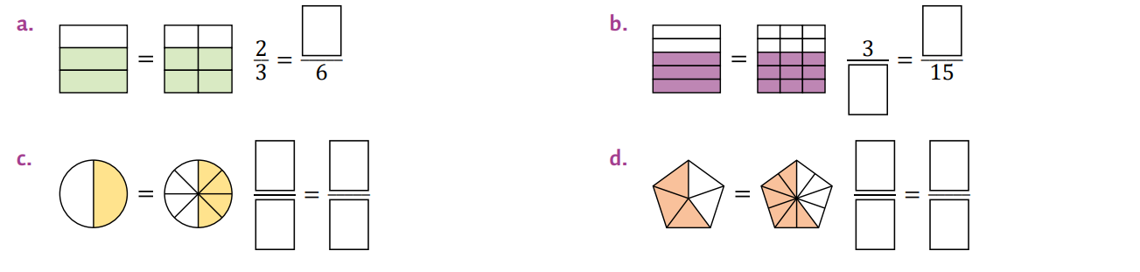  $$\frac{3}{5}=\frac{6}{10}$$

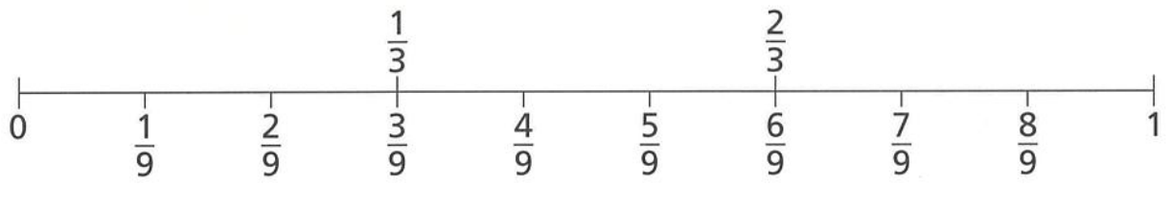
- What equivalent fractions can be seen on the number line?

$$\frac{1}{3}=\frac{3}{9},\frac{2}{3}=\frac{6}{9}$$
- What equivalent fractions are represented by each pair of diagrams?
$$\frac{5}{6}=\frac{10}{12}$$ | $$\frac{3}{4}=\frac{6}{8}$$ | $$\frac{5}{10}=\frac{1}{2}$$ | 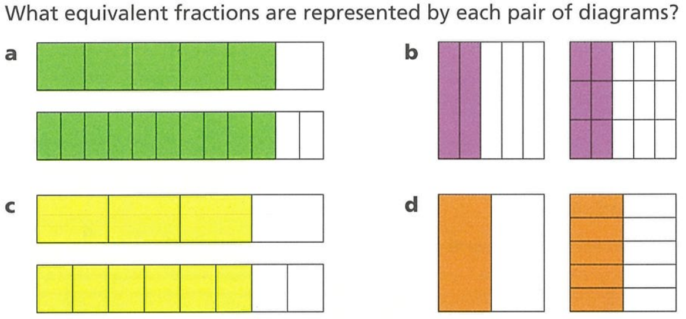  $$\frac{6}{15}=\frac{2}{5}$$
- Read the examples carefully and answer the questions.
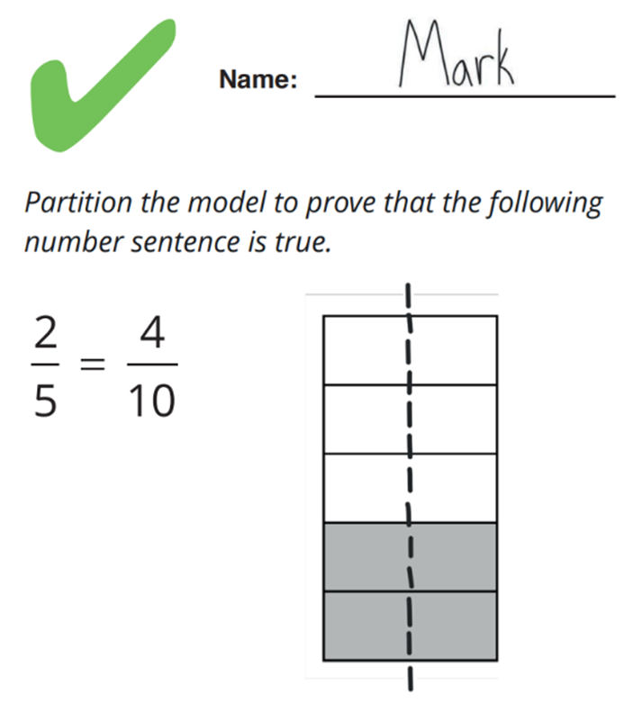 | After Mark partitioned the model, what happened to the size of each part?  The size of each part was halved  What happened to the number of parts?  The number of parts doubled  Even though the size and number of parts changed, why is $\frac{2}{5}$ equal to $\frac{4}{10}$?  The shaded amount is still the same  Partition the model to prove that the following number sentence is true.  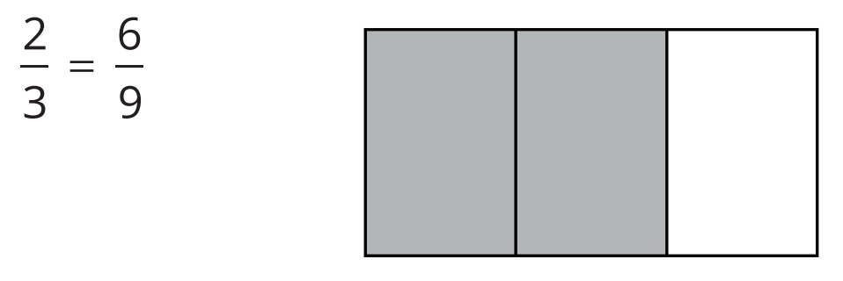

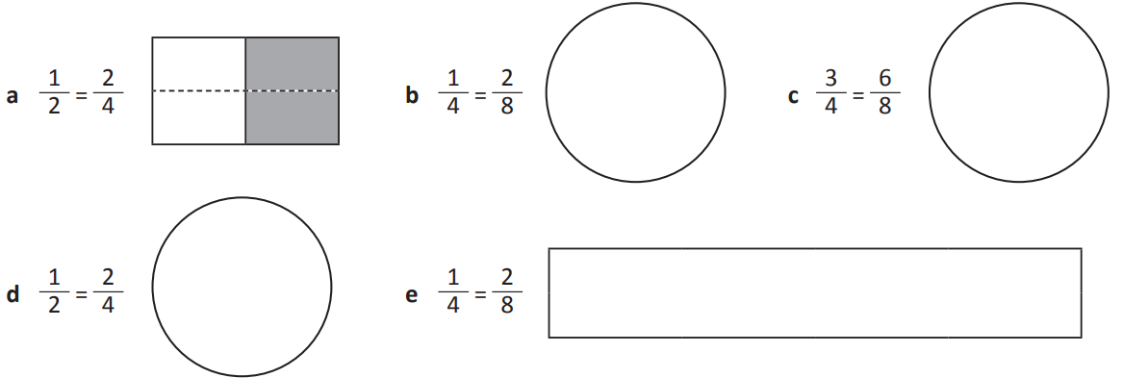
- Divide and shade the shapes to show equivalent fractions.

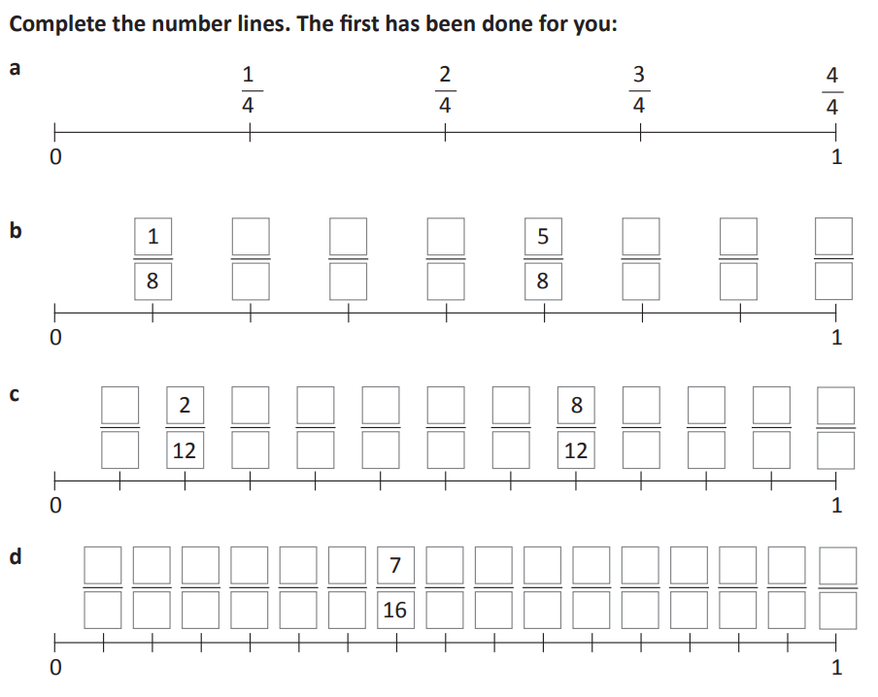
- Complete the number lines. The first has been done for you.

Complete the following using the number lines above.
$$\frac{1}{4}=\frac{2}{8}=\frac{3}{12}=\frac{4}{16}$$ | $$\frac{1}{2}=\frac{4}{8}=\frac{6}{12}=\frac{8}{16}$$ | 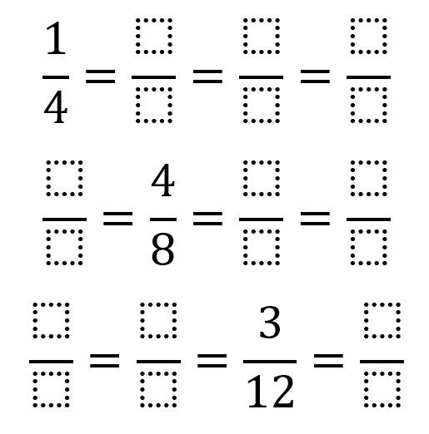  $$\frac{1}{4}=\frac{2}{8}=\frac{3}{12}=\frac{4}{16}$$
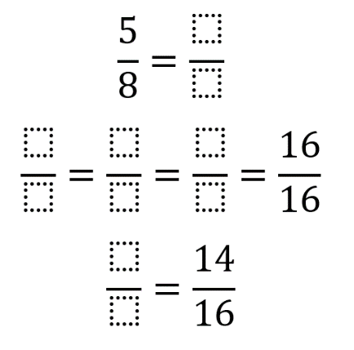  $$\frac{10}{16}$$ | $$\frac{4}{4}=\frac{8}{8}=\frac{12}{12}$$ | 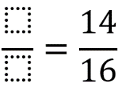  $$\frac{7}{8}$$

Development
- Produce equivalent fractions by shading these circles.
$$\frac{1}{2}=\frac{ }{4}=\frac{ }{6}$$  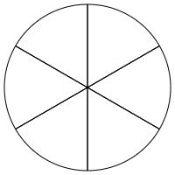  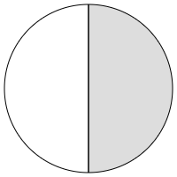  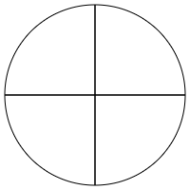  $$\frac{2}{4}=\frac{3}{6}$$ | $$\frac{2}{3}=\frac{ }{6}=\frac{ }{9}$$  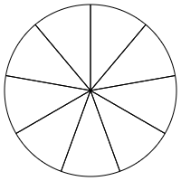  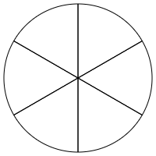  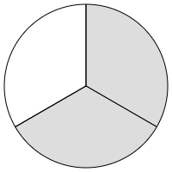  $$\frac{4}{6}=\frac{6}{9}$$
$$\frac{2}{5}=\frac{ }{10}=\frac{ }{15}$$  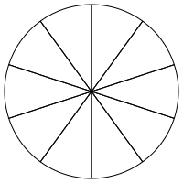  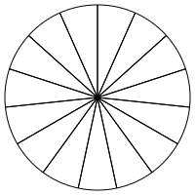  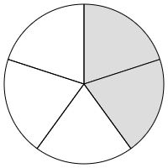  $$\frac{4}{10}=\frac{6}{15}$$ | $$\frac{ }{4}=\frac{2}{8}=\frac{ }{12}$$  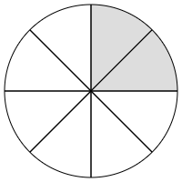  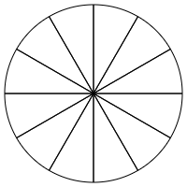  $$\frac{1}{4}=\frac{3}{12}$$

- Using the shapes and the number lines, show that $\frac{2}{3}=\frac{4}{6}$
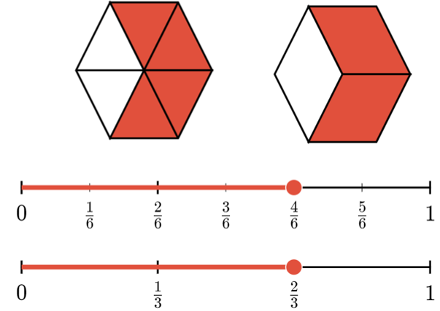


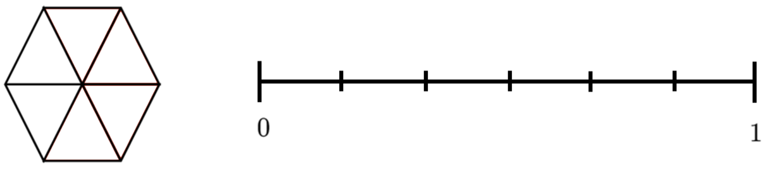

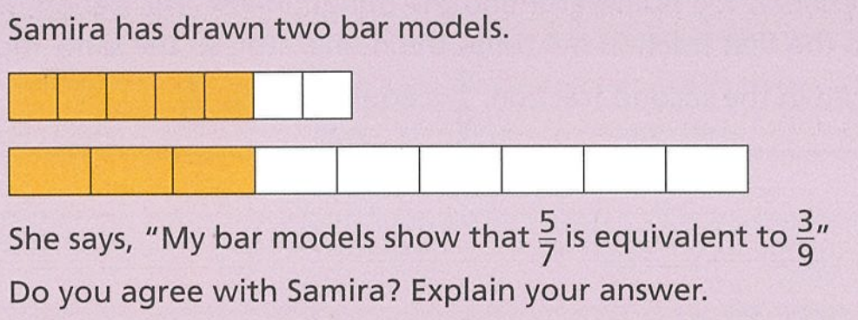
- Samira has drawn two bar models.

She says that $\frac{5}{7}=\frac{3}{9}$
Explain why she is incorrect.

The length of the two bars is different, so the “whole” is different.
The whole must be the same size to compare fractions directly.

Producing Equivalent Fractions using the Rule

- Equivalent Fractions
- Equivalent Fractions: https://www.geogebra.org/m/b58khnqu
To create equivalent fractions:
Multiply or divide both the numerator and denominator by the same number.
This is the same as multiplying or dividing by 1.
$$\frac{1}{2}×1=\frac{1}{2}$$
$$\frac{1}{2}×\frac{2}{2}=\frac{2}{4}$$

- Example Produce equivalent fractions
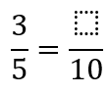  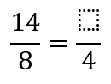  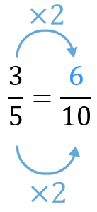 | 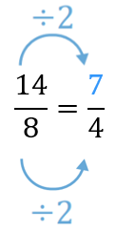

- Guided Practice
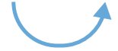
Determine the equivalent fraction.
- $\frac{4}{5}=\frac{ }{20}$ | - $\frac{40}{25}=\frac{ }{5}$
- $\frac{2}{3}=\frac{ }{12}$ | - $\frac{10}{20}=\frac{ }{2}$
- $\frac{12}{15}=\frac{ }{5}$ | - $\frac{6}{8}=\frac{ }{24}$

- Key Ideas
- To produce equivalent fractions, multiply or divide the ………………… and ……………… by the same number. This is the same as multiplying or dividing by ……

Foundation
- Fill in the missing number to produce equivalent fractions.
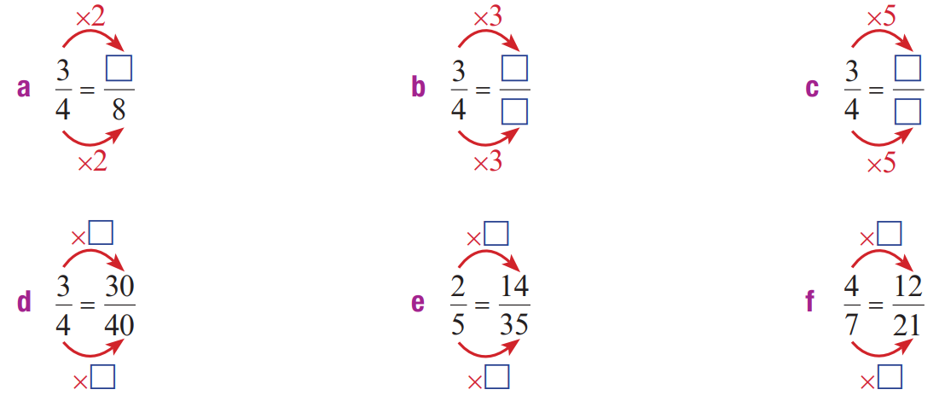  6 | $$\frac{9}{12}$$ | $$\frac{15}{20}$$ | $$×10$$ | $$×7$$ | $$×3$$

- Fill in the missing number to produce equivalent fractions.
$$×5$$ | $$÷8$$ | 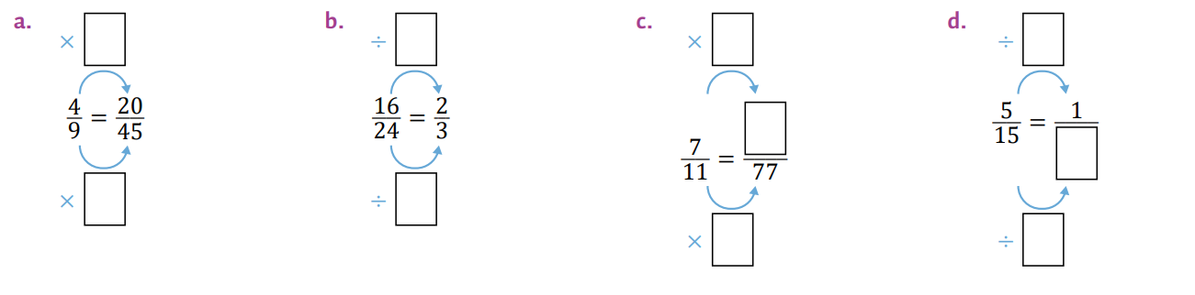  $$×7$$ | $$÷5$$

- Write four equivalent fractions for these fractions.
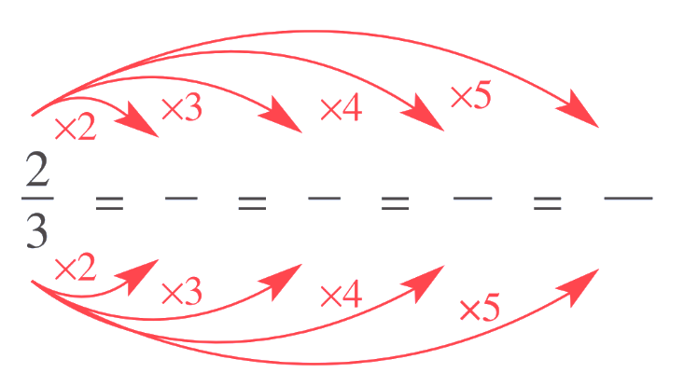  $$\frac{2}{3}=\frac{6}{9}=\frac{8}{12}=\frac{10}{15}$$ | $$\frac{3}{5}=\frac{}{}=\frac{}{}=\frac{}{}=\frac{}{}$$  Many answers possible

- Write these equivalent fractions.
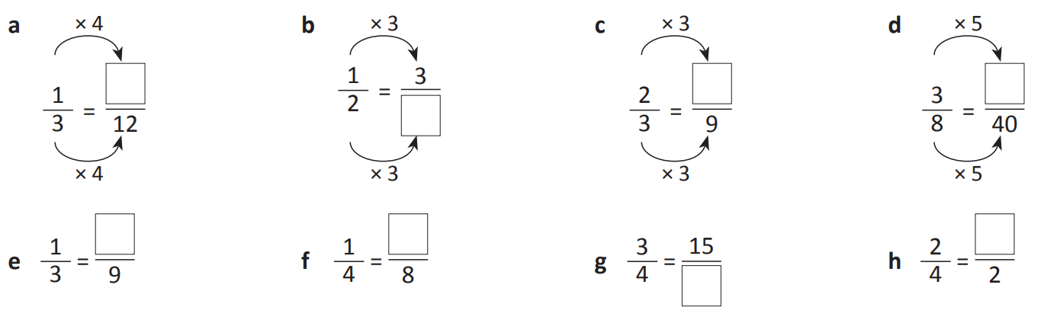  4 | 6 | 6 | 15
3 | 2 | 20 | 1

Development
- Find the unknown value to make the equation true.
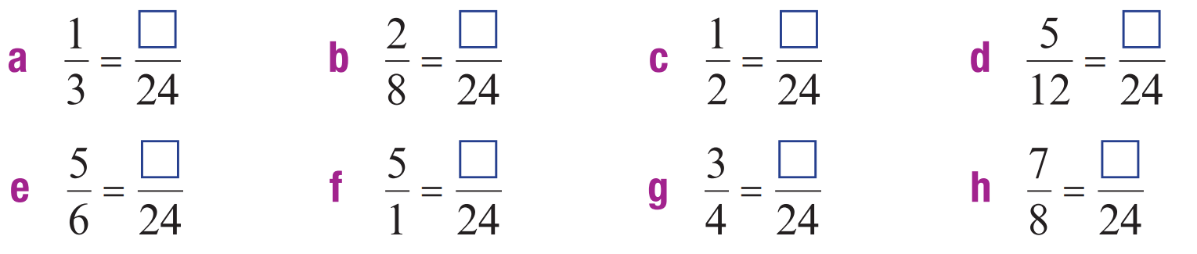  8 | 6 | 12 | 10
20 | 120 | 18 | 21

- Find the unknown value to make the equation true.
6 | 10 | 15 | 90
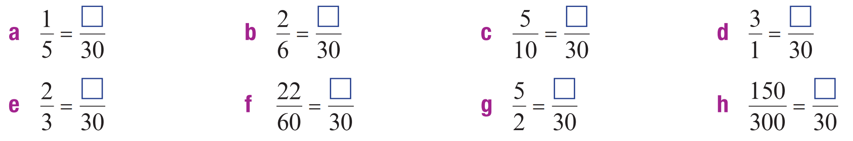  20 | 11 | 75 | 15

- Find the unknown value to make the equation true.
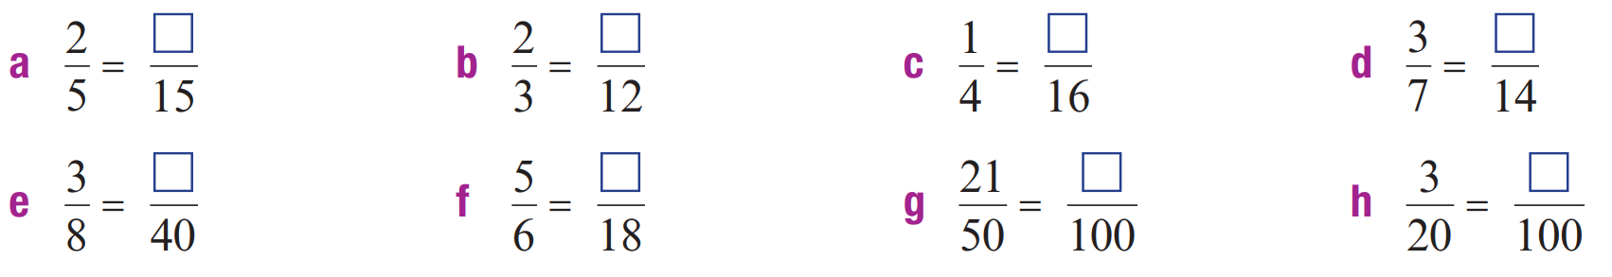  6 | 8 | 4 | 6
15 | 15 | 42 | 15

- Find the unknown value to make the equation true.
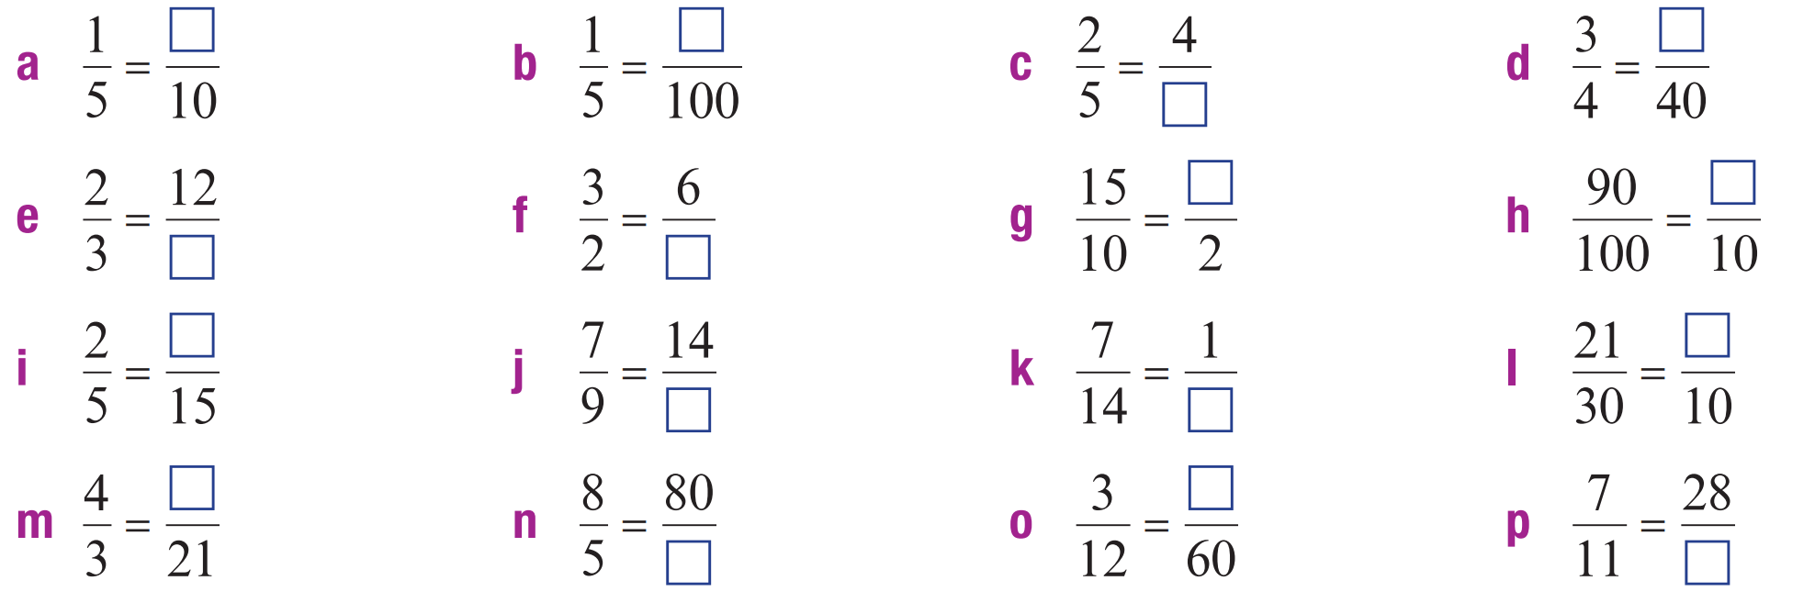  2 | 20 | 10 | 30
18 | 4 | 3 | 9
6 | 18 | 2 | 7
28 | 50 | 15 | 44

- Complete these equivalent fractions (hint: whole numbers have denominator of 1).
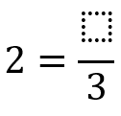  6 | 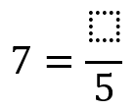  35 | 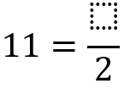  22 | 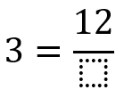  4
- Read the example carefully and answer the questions.
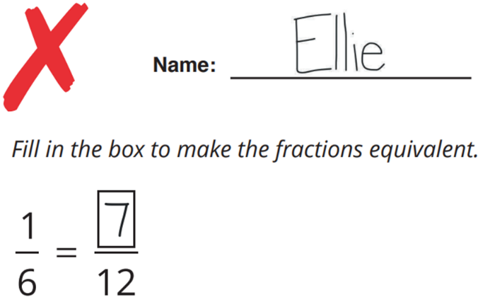 | Shade the two diagrams below to show that $\frac{1}{6}$ is not equivalent to $\frac{7}{12}$  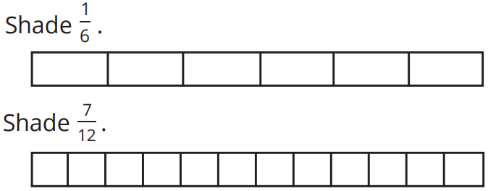  Ellie added instead of multiplying. Complete the number sentence to show what number Ellie should have multiplied by  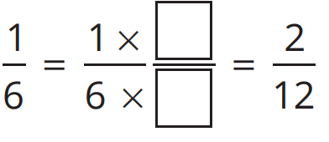  $$×2$$

- Fill in the missing numbers to complete these equivalent fractions.

2, 12, 10, 20, 300

1, 3, 24, 20, 40

- Fill in the blanks to make these fractions equivalent.
6 | 8 | 14 | 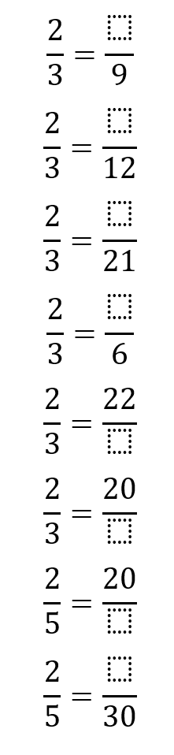  4
33 | 30 | 50 | 12

- Find the numerator of the fraction equivalent to two-thirds with a denominator of 15.

$$\frac{2}{3}=\frac{10}{15}$$
- Circle the numbers that could be the denominator of a fraction that is equivalent to one-quarter.
8, 12, 15, 19, 22, 24, 30, 32, 35, 40
Explain your reasoning.
8, 12, 24, 40. These are multiples of 4.

Mastery
- Complete the following.
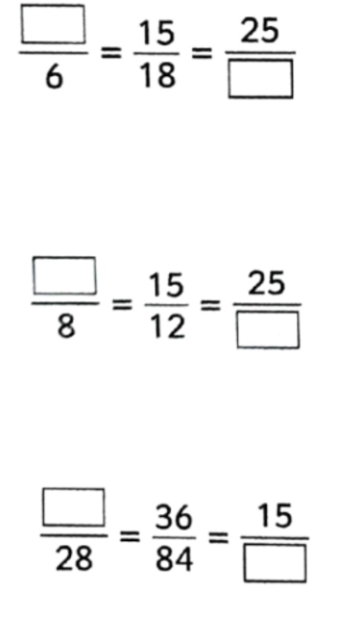  5, 30 | 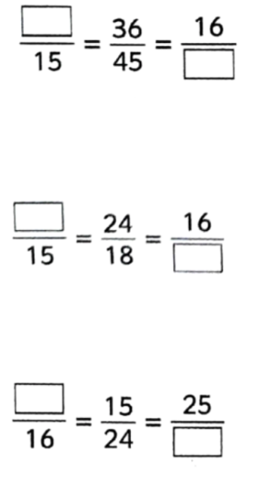  12, 20 | 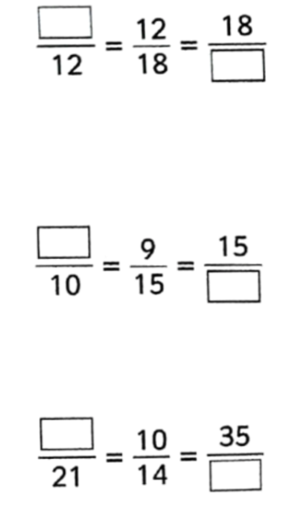  8, 27
10, 20 | 20, 12 | 6, 25
12, 35 | 10, 40 | 15, 49

- Complete the following.
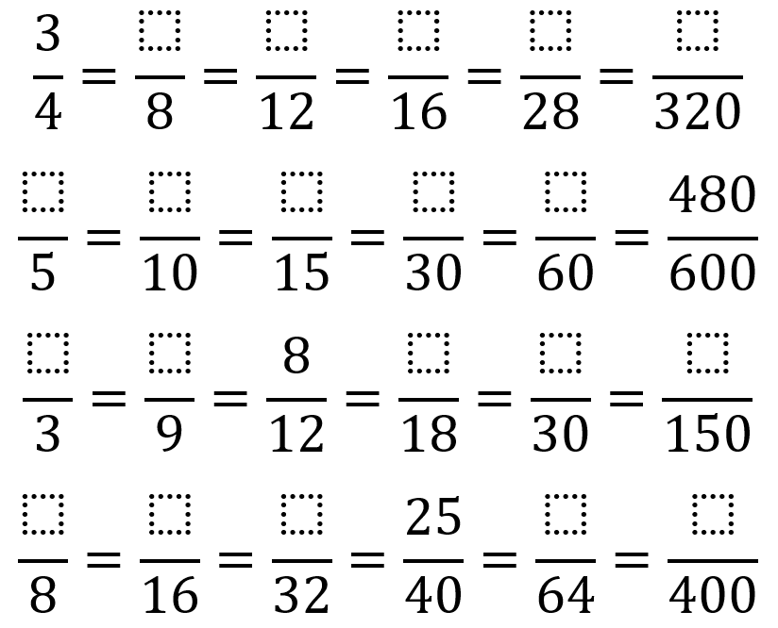

6, 8, 12, 21, 240

4, 8, 12, 24, 48

2, 6, 12, 20, 100

5, 10, 20, 40, 250
- Write either $=$ or $≠$ between the fractions to state whether these fractions are equivalent or not.
≠ | = | ≠
≠ | = | 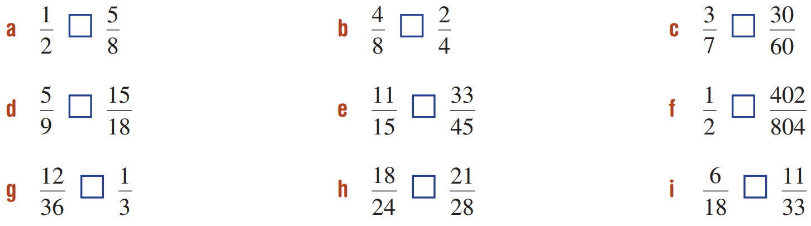  =
= | = | =

- Explain why this working out is incorrect.
$$\frac{4}{5}=\frac{4^{2}}{5^{2}}=\frac{16}{25}$$

By squaring the numerator and denominator, you have multiplied numerator by 4 and denominator by 5.
To keep a fraction equivalent, you must multiply the numerator and denominator by the same number.
- Flo got $\frac{3}{4}$ of the questions on an online quiz correct.
She then got $\frac{21}{28}$ of the questions on a written test correct.
Flo thinks she did better on the written test than on the online test because 21 is greater than 3.
Explain why she is incorrect.

The two fractions are equivalent, so she performed the same on both tests.
- These fractions are equivalent.
Determine five possible pairs of values that could make the statement correct.
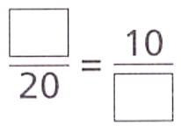

Many answers possible.
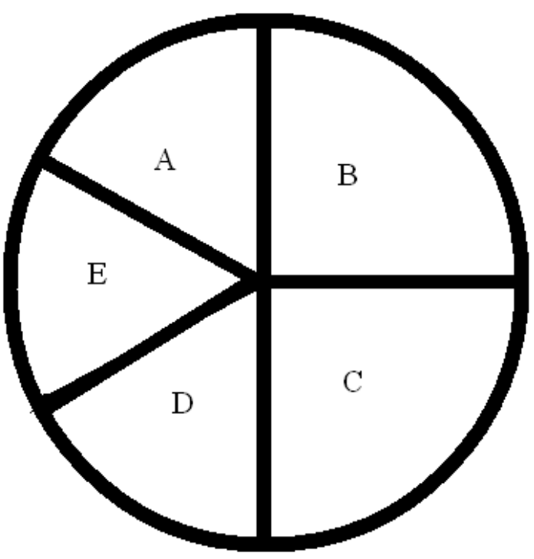
- What fraction of the circle is part D?

D is one sixth. Six of D would make a whole circle.
- For each of the diagrams shown, work out what fraction of the rectangle is shaded.
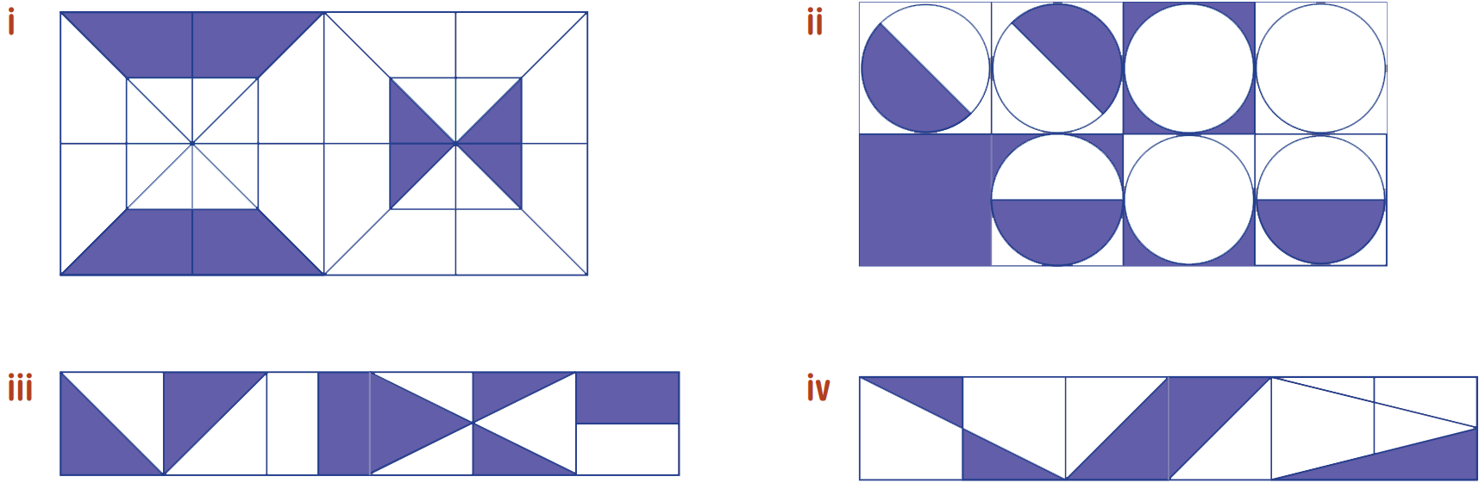  $$\frac{1}{4}$$ | $$\frac{3}{8}$$
$$\frac{1}{2}$$ | $$\frac{1}{3}$$

Simplifying Fractions

- Simplifying Fractions
Simplifying means writing an equivalent fraction with smaller numbers.
Divide both the numerator and denominator by their common factors.
A fully simplified fraction has no common factors between the numerator and denominator.

- Example Simplify fractions
Simplify $\frac{8}{12}$  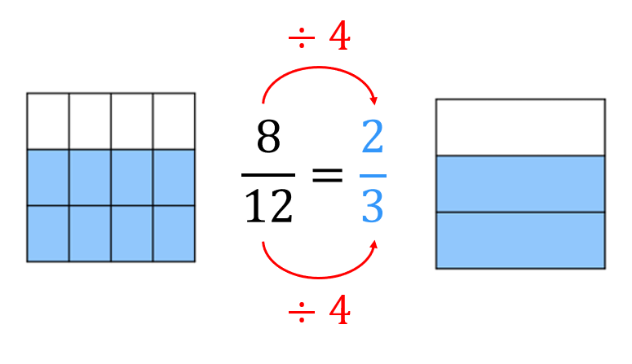 | To simplify fractions, we divide the numerator and denominator by common ………………  In the model, simplifying a fraction means reducing the number of p…………… while keeping the a………… the same.
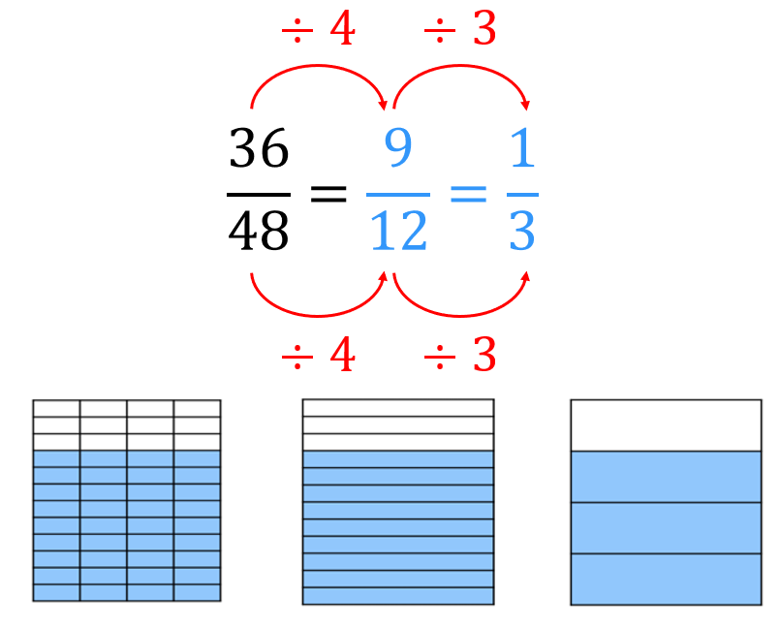  Simplify $\frac{36}{48}$ | A fraction is fully simplified when the numerator and denominator have no more common ………………  To simplify in a single step, we divide by the ……………… ……………… …………

- Guided Practice
Fully simplify:
$$\frac{9}{21}=\frac{ }{ }$$ | $$\frac{15}{45}=\frac{ }{ }$$
$$\frac{8}{24}=\frac{ }{ }$$ | $$\frac{12}{72}=\frac{ }{ }$$

- Key Ideas
- A fully simplified fraction has no ……………… ………………… between the numerator and denominator.
- To simplify, ………………… the numerator and denominator by the …………

Foundation
- Rewrite these fractions in the simplest way (split into the least equal pieces)
$$\frac{6}{12}=\frac{}{}$$  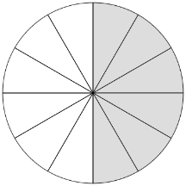  $$\frac{1}{2}$$ | $$\frac{6}{8}=\frac{}{}$$  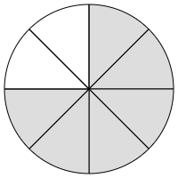  $$\frac{3}{4}$$
$$\frac{6}{9}=\frac{}{}$$  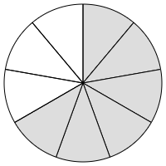  $$\frac{2}{3}$$ | $$\frac{2}{3}=\frac{}{}$$  Can’t simplify

- Fill in the missing number to simplify these fractions.
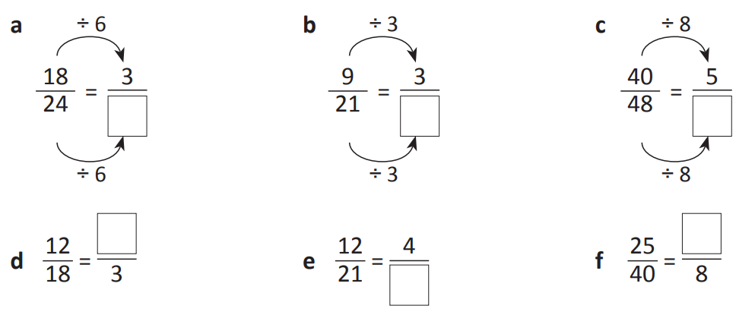  4 | 7 | 6
2 | 7 | 5

- Fill in the missing number to simplify these fractions.
$$\frac{1}{3}$$ | $$÷4$$ | $$÷2$$ | $$÷3$$ | $$÷4$$ | 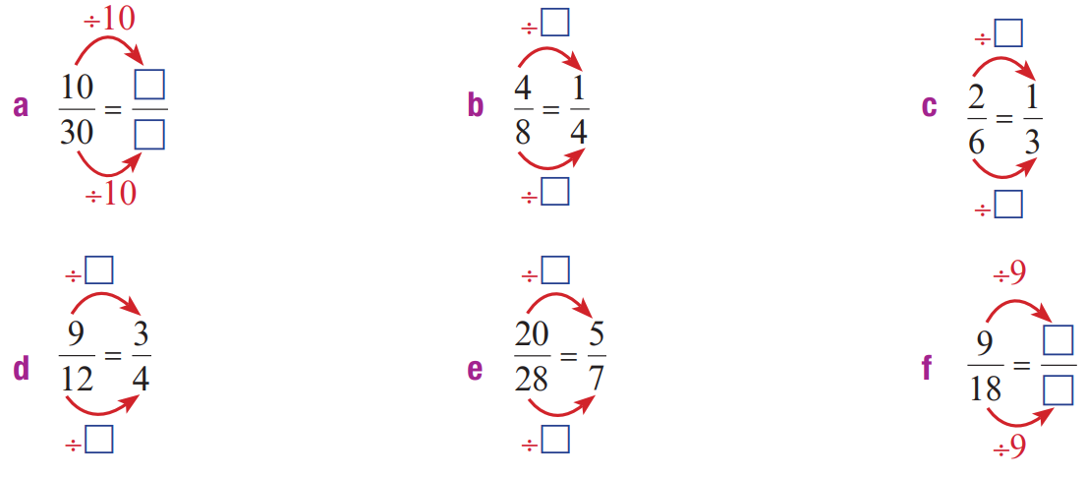  $$\frac{1}{2}$$

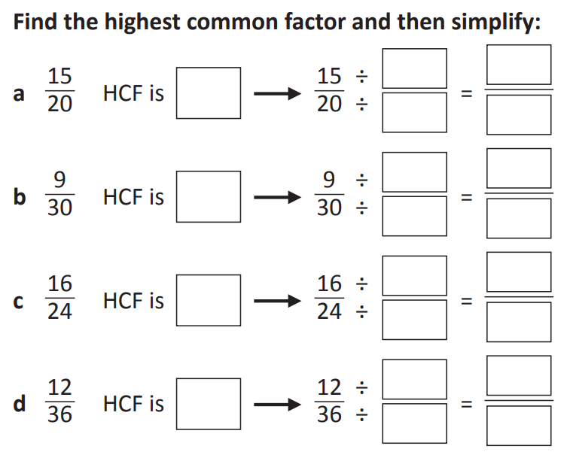
- Find the HCF and then simplify

$$÷5, \frac{3}{4}$$

$$÷3, \frac{3}{10}$$

$$÷8, \frac{2}{3}$$

$$÷12, \frac{1}{3}$$
- Wally says he has simplified these fractions as much as he can. Is he correct?
If not, find the simplest fraction in each case.
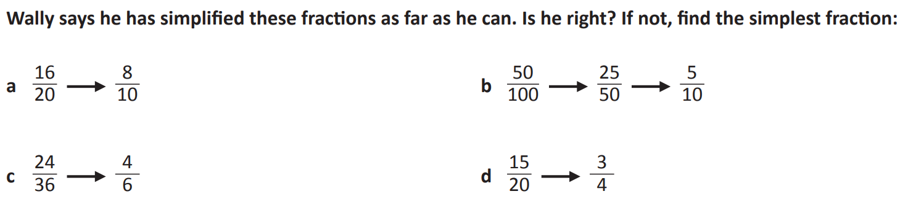  No  $$\frac{4}{5}$$ | No  $$\frac{1}{2}$$
No  $$\frac{2}{3}$$ | Yes

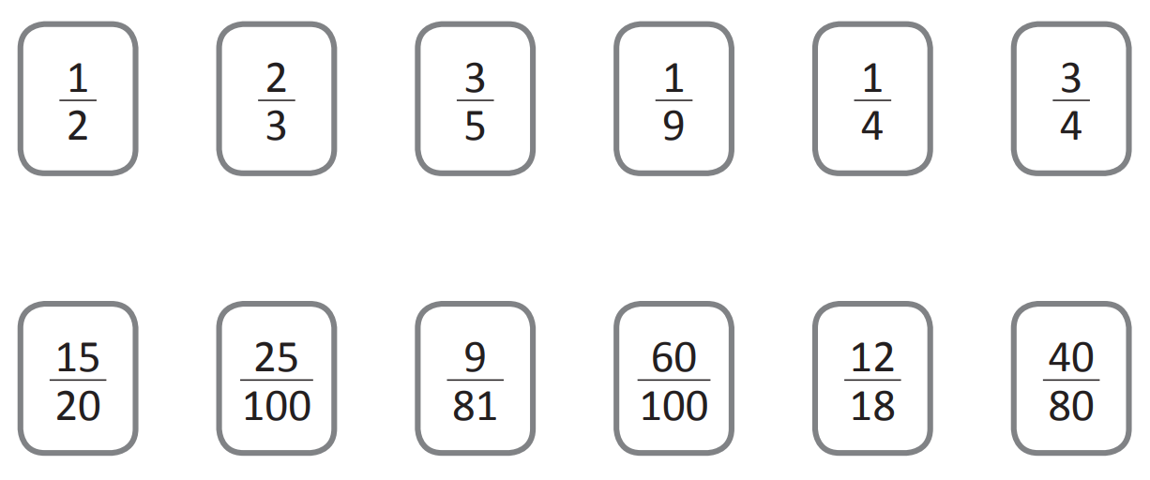
- Match up these fractions to their simplest form.

Development
- Simplify the following fractions.
- $$\frac{6}{12}=$$  $$\frac{1}{2}$$ | - $$\frac{4}{12}=$$  $$\frac{1}{3}$$ | - $$\frac{3}{12}=$$  $$\frac{1}{4}$$ | - $$\frac{9}{12}=$$  $$\frac{3}{4}$$
$$\frac{18}{24}=$$  $$\frac{3}{4}$$ | - $$\frac{9}{24}=$$  $$\frac{3}{8}$$ | - $$\frac{6}{16}=$$  $$\frac{3}{8}$$ | - $$\frac{16}{6}=$$  $$\frac{8}{3}$$
$$\frac{16}{16}=$$  $$1$$ | - $$\frac{32}{16}=$$  $$2$$ | - $$\frac{16}{32}=$$  $$\frac{1}{2}$$ | - $$\frac{15}{31}=$$  $$\frac{15}{31}$$

- Write the following fractions in simplest form.
If you can’t identify the HCF straight away, start by dividing the numerator and denominator by any common factor. You will eventually get the answer.
- $$\frac{15}{20}=$$  $$\frac{3}{4}$$ | - $$\frac{12}{18}=$$  $$\frac{2}{3}$$ | - $$\frac{10}{30}=$$  $$\frac{1}{3}$$ | - $$\frac{8}{22}=$$  $$\frac{4}{11}$$
$$\frac{14}{35}=$$  $$\frac{2}{5}$$ | - $$\frac{2}{22}=$$  $$\frac{1}{11}$$ | - $$\frac{8}{56}=$$  $$\frac{1}{7}$$ | - $$\frac{9}{27}=$$  $$\frac{1}{3}$$
$$\frac{35}{45}=$$  $$\frac{7}{9}$$ | - $$\frac{36}{96}=$$  $$\frac{3}{8}$$ | - $$\frac{120}{144}=$$  $$\frac{5}{6}$$ | - $$\frac{700}{140}=$$  $$5$$

- Express these times as fractions of an hour in simplest form.
- 30 minutes  $$\frac{1}{2}$$ | - 60 minutes  1
- 20 minutes  $$\frac{1}{3}$$ | - 15 minutes  $$\frac{1}{4}$$
- 45 minutes  $$\frac{3}{4}$$ | - 5 minutes  $$\frac{1}{12}$$
- 3 minutes  $$\frac{1}{20}$$ | - 2 minutes  $$\frac{1}{30}$$

Mastery
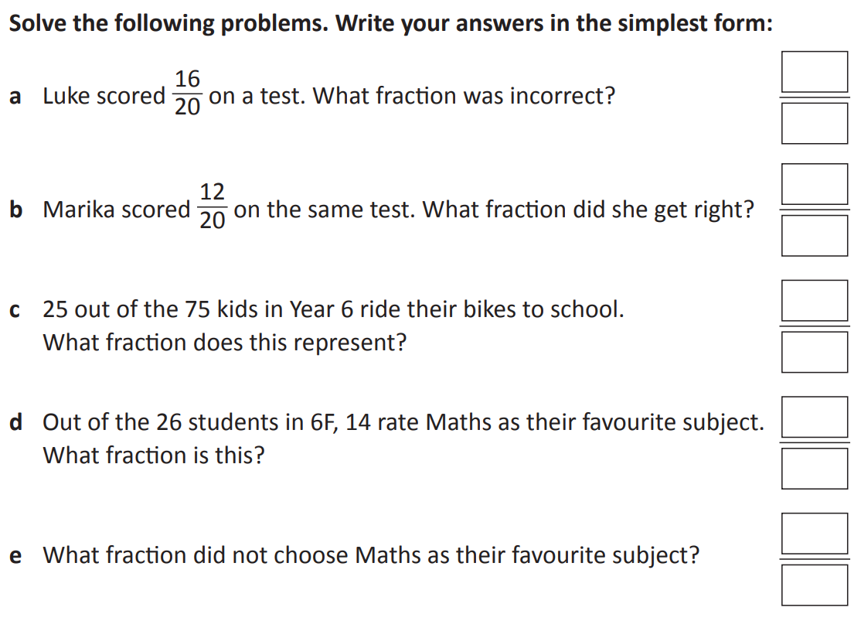
- Solve the following problems by answering in simplest form.

$$\frac{1}{5}$$

$$\frac{3}{5}$$

$$\frac{1}{3}$$

$$\frac{7}{13}$$

$$\frac{6}{13}$$

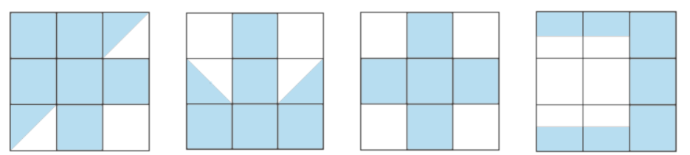
- Which of these shows exactly two thirds?

Second pattern
- What fraction of the shape is shaded?
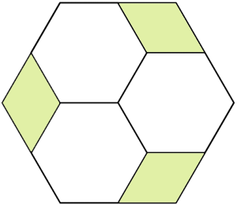

By splitting the shape based on the diamond, there are 3 shaded out of 12.
$$\frac{1}{4}$$
- Explain why $\frac{1}{2}$ of this diagram is shaded,
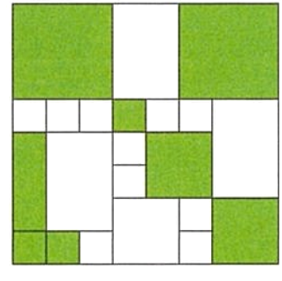

By splitting the shape up based on the smallest square, there are 32 shaded out of 64

Comparing Fractions: Same Denominator/Same Numerator

- Comparing Fractions
Same Denominator  The larger numerator is the larger value.  $$\frac{1}{7}<\frac{5}{7}$$  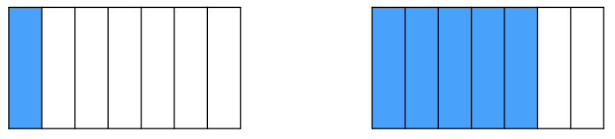 | Same Numerator  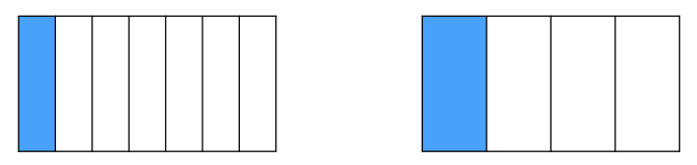  The smaller denominator is the larger value.  $$\frac{1}{7}<\frac{1}{4}$$

- Compare fractions with the same denominator/numerator
Choose the correct relational symbol (<, >) to put in the box.
$$\frac{5}{6} \frac{3}{6}$$ |  | $$\frac{3}{4} \frac{6}{4}$$    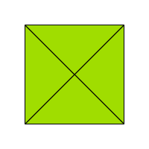  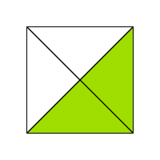
$$\frac{1}{4} \frac{1}{3}$$  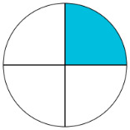  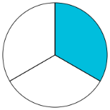 |  | $$\frac{2}{3} \frac{2}{5}$$  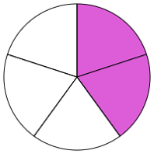  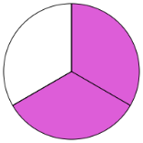
$$\frac{2}{3} \frac{5}{3}$$ | $$\frac{2}{3} \frac{2}{5}$$ |  | $$\frac{3}{6} \frac{3}{7}$$

Foundation
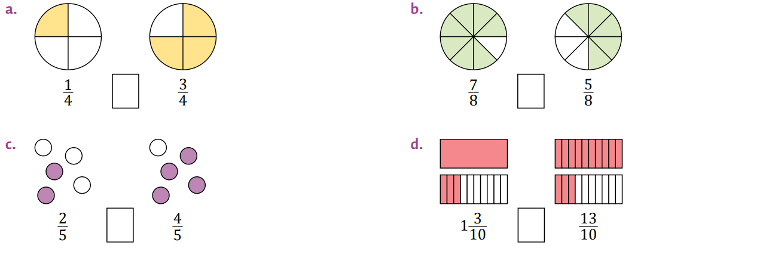
- Compare these fractions.
< | >
< | =
- Compare these fractions using a number line.
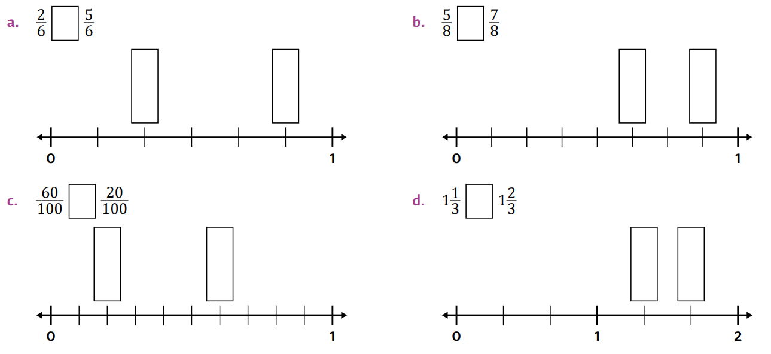  < | <
> | <
- Circle the largest fraction in each list
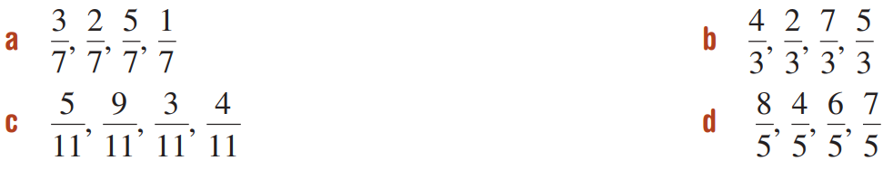  $$\frac{5}{7}$$ | $$\frac{7}{3}$$
$$\frac{9}{11}$$ | $$\frac{8}{5}$$

- Circle the largest fraction in each list.
- $\frac{1}{4},\frac{1}{7},\frac{1}{12},\frac{1}{3}$  $$\frac{1}{3}$$ | - $\frac{4}{12},\frac{4}{1},\frac{4}{9},\frac{4}{2}$  $$\frac{4}{1}$$
- $\frac{2}{3},\frac{2}{5},\frac{2}{12},\frac{2}{4}$  $$\frac{2}{3}$$ | - $\frac{1}{123},\frac{1}{2241},-\frac{1}{2},\frac{1}{42}$  $$\frac{1}{42}$$

- Read the examples carefully and answer the questions.
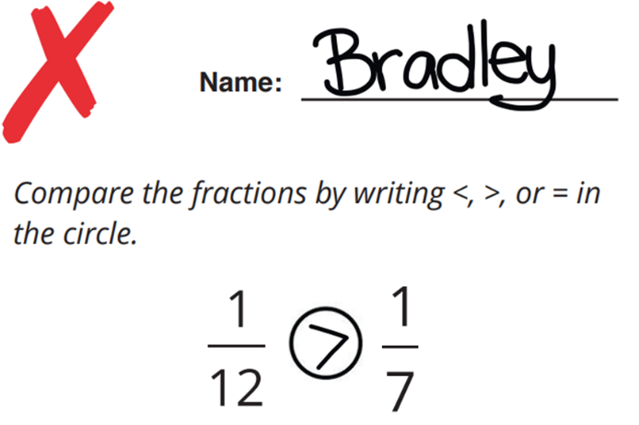 | Bradley compared the denominators since the numerators are the same. However, he did not do it correctly. Help Bradley check his work by shading the diagrams below to represent each fraction.  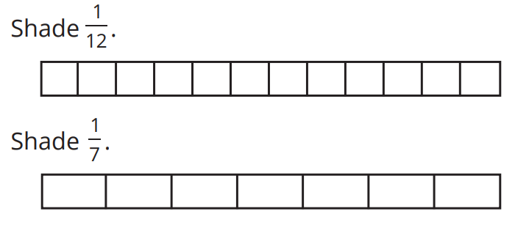  Explain why $\frac{1}{12}$is actually less than $\frac{1}{7}$.  In 1/7, the whole is split into less pieces, so each piece is larger.  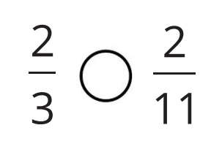  Compare the fractions by writing <, > or = in the circle.  >
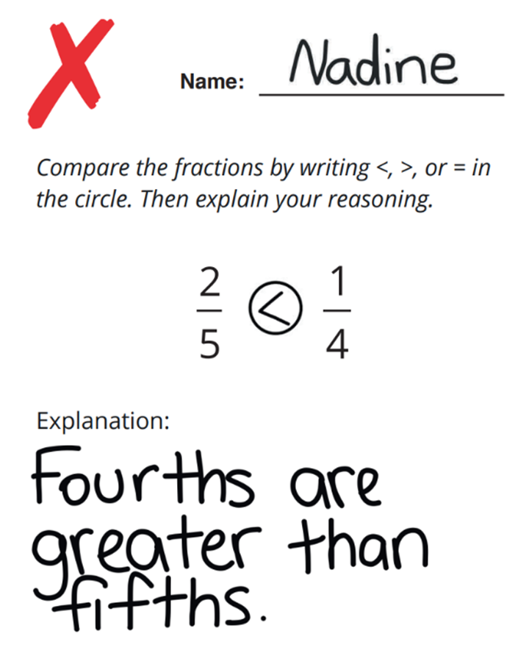 | Nadine is correct that fourths are greater than fifths. Use the diagrams above to explain why that doesn’t mean $\frac{1}{4}$ is greater than $\frac{2}{5}$  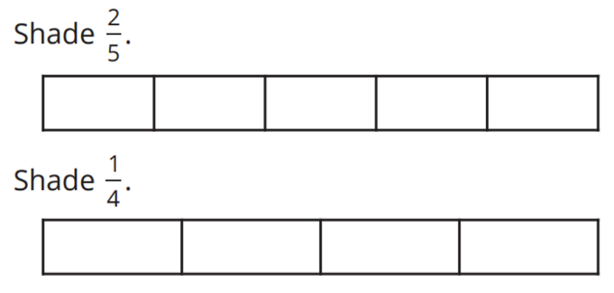  Compare the fractions by writing <, > or = in the circle.  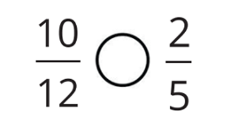  >

Comparing Fractions: Related Denominators

- Review
- Determine LCM
- 4 and 6 | - 5 and 10 | - 8 and 6

- Determine LCM of denominators
- $\frac{}{3} \frac{}{12}$ | - $\frac{}{4} \frac{}{8}$ | - $\frac{}{6} \frac{}{18}$
- $\frac{}{60} \frac{}{20}$ | - $\frac{}{15} \frac{}{45}$ | - $\frac{}{8} \frac{}{20}$

- Determine equivalent fraction
- $\frac{3}{7}=\frac{}{21}$ | - $\frac{10}{9}=\frac{}{45}$ | - $\frac{}{13}=\frac{21}{39}$
- $\frac{6}{10}=\frac{}{15}$ | - $\frac{92}{150}=\frac{}{75}$ | - $\frac{2}{24}=\frac{}{72}$

- Compare fractions with the same numerator/denominator
- $\frac{1}{2} \frac{1}{3}$ | - $\frac{1}{5} \frac{1}{3}$ | - $\frac{2}{5} \frac{2}{11}$
- $\frac{3}{8} \frac{3}{2}$ | - $\frac{4}{8} \frac{7}{8}$ | - $\frac{15}{13} \frac{3}{13}$
- $\frac{16}{78} \frac{59}{78}$ | - $\frac{4}{6} \frac{1}{3}$ | - $\frac{8}{20} \frac{2}{5}$

- Comparing Fractions with Related Denominators
- Comparing Fractions: https://www.geogebra.org/m/madk3hpt
Related denominators are when one denominator is a multiple of the other.
To compare fractions with related denominators:
- Rewrite the fractions with the lowest common multiple of the denominators.
- Compare the numerators.

- Example Compare fractions with related denominators
$$\frac{3}{5} \frac{7}{10}$$  1. Lowest common denominator  $$\frac{3}{5}×\frac{2}{2}=\frac{6}{10} \frac{7}{10}$$  2. Compare  <  $$\frac{3}{5} \frac{7}{10}$$ | $$\frac{17}{24} \frac{5}{8}$$  1. Lowest common denominator  $$\frac{17}{24} \frac{15}{24}=\frac{5}{8}×\frac{3}{3}$$  2. Compare  >  $$\frac{17}{24} \frac{5}{8}$$

- Guided Practice
Choose the correct relational symbol (<, >, =) to put in the box.
$$\frac{2}{3} \frac{9}{15}$$ | $$\frac{11}{12} \frac{5}{6}$$
$$\frac{3}{4} \frac{6}{8}$$ | $$\frac{2}{6} \frac{7}{18}$$

- Key Ideas
- To compare two fractions, first make the ………………………… the same, then compare the …………………………

Foundation
- Determine the larger fraction by writing both fractions with the same denominator.
  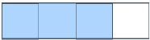  $$\frac{1}{2} \frac{3}{4}$$  $$\frac{}{4}$$  $$\frac{2}{4}, <$$ | $$\frac{2}{3} \frac{6}{9}$$  $$\frac{}{9}$$  $$\frac{6}{9}, =$$
$$\frac{3}{8} \frac{2}{4}$$  $$\frac{}{8}$$  $$<\frac{4}{8}$$ | 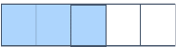  $$\frac{1}{2} \frac{3}{5}$$  $$\frac{}{10} \frac{}{10}$$  $$\frac{5}{10}<\frac{6}{10}$$
- Compare these fractions by making their denominators the same.
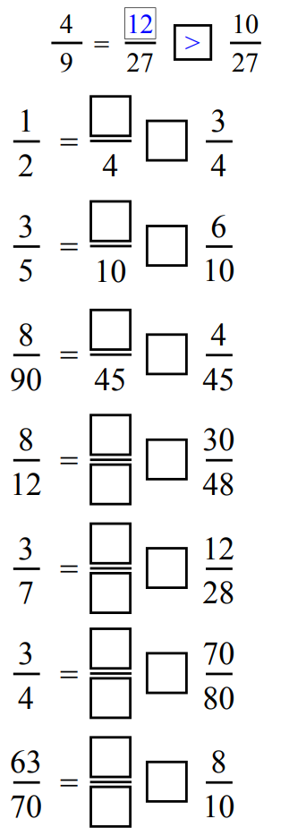 | 2, < | 6, =
4, = | $$\frac{32}{48}>$$ | $$\frac{12}{28}=$$
$$\frac{60}{80}<$$ | $$\frac{9}{10}>$$
- Compare these fractions using the $<,=$ or $>$ symbols.
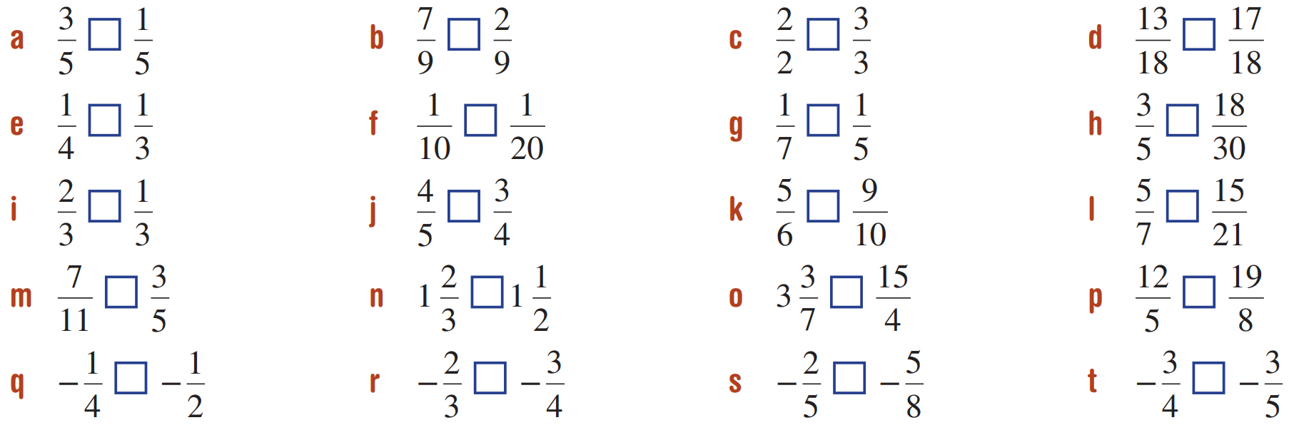  > | > | =
< | < | >
= | > | =

Development
- What fraction is the arrow pointing to?
(Hint: write an equivalent fraction with a different denominator)
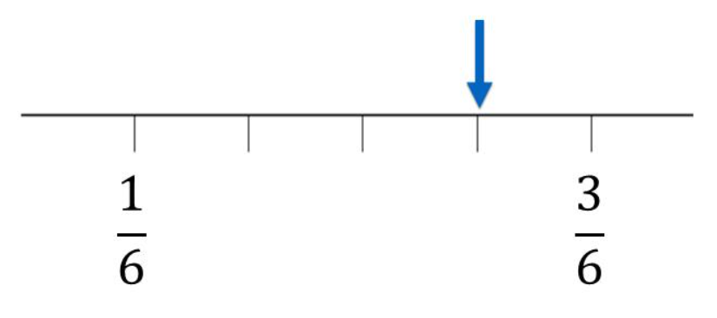  $$\frac{5}{12}$$ | 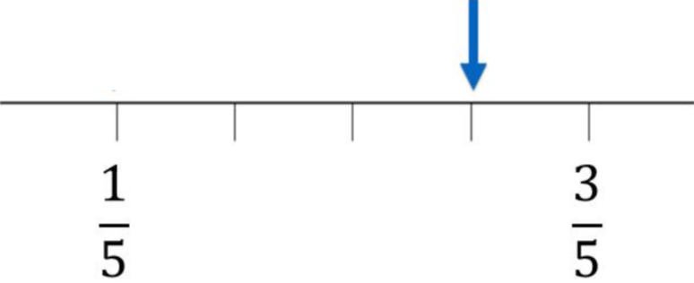  $$\frac{1}{2}$$ | 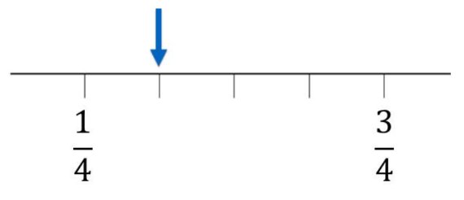  $$\frac{3}{8}$$

- Which of these fractions could not be placed between the fractions marked on the number line?
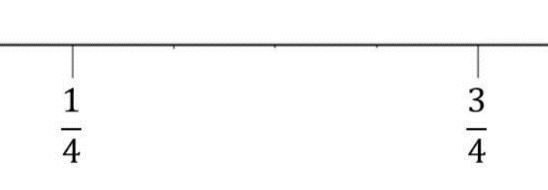

- $\frac{10}{12}$ | - $\frac{1}{3}$ | - $\frac{24}{48}$ | - $\frac{17}{32}$
$$\frac{10}{12}, as it is larger than\frac{3}{4}$$
- Which of these fractions could not be placed between the fractions marked on the number line?
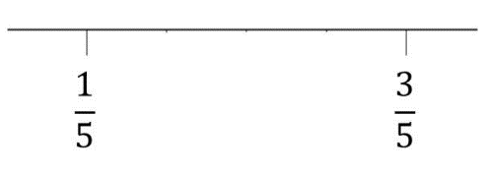

- $\frac{2}{5}$ | - $\frac{75}{150}$ | - $\frac{1}{4}$ | - $\frac{10}{15}$
$$\frac{10}{15}, as it is larger than\frac{3}{5}$$
- What fraction is the arrow pointing to on the number line?
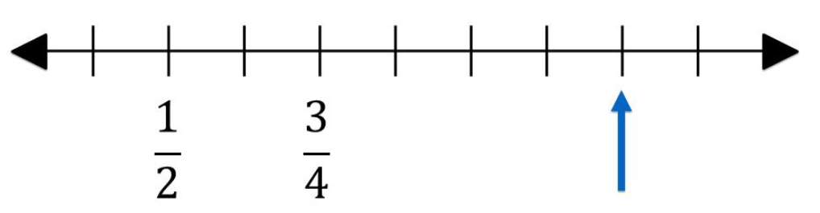

By changing denominators to 8, the arrow is pointing to $\frac{10}{8}$ = $\frac{5}{4}$.

Comparing Fractions: Unrelated Denominators

- Review
- Determine LCM
- 5 and 12 | - 9 and 12 | - 12 and 16
- 18 and 3 | - 10 and 15 | - 8 and 12

- Determine LCM of denominators
- $\frac{}{9} \frac{}{12}$ | - $\frac{}{3} \frac{}{7}$ | - $\frac{}{8} \frac{}{9}$
- $\frac{}{15} \frac{}{5}$ | - $\frac{}{4} \frac{}{10}$ | - $\frac{}{15} \frac{}{6}$

- Compare fractions with the related denominator
- $\frac{3}{8} \frac{4}{8}$ | - $\frac{2}{3} \frac{4}{9}$ | - $\frac{1}{2} \frac{3}{8}$
- $\frac{3}{5} \frac{6}{10}$ | - $\frac{17}{12} \frac{5}{4}$ | - $\frac{3}{4} \frac{5}{8}$

- Comparing Fractions with Unrelated Denominators
- Comparing Fractions: https://www.geogebra.org/m/madk3hpt
To compare fractions with unrelated denominators:
- Rewrite the fractions with the lowest common multiple of the denominators.
- Compare the numerators.
- To make a common denominator, multiply the numerator and denominator of each fraction by the other fraction’s denominator.

- Example Compare fractions with related denominators
$$\frac{3}{8} \frac{2}{5}$$  1. Lowest common denominator  $$\frac{3}{8}×\frac{5}{5}=\frac{15}{40} \frac{16}{40}=\frac{2}{5}×\frac{8}{8}$$  2. Compare  <  $$\frac{3}{8} \frac{2}{5}$$ | $$\frac{17}{15} \frac{11}{10}$$  1. Lowest common denominator  $$\frac{17}{15}×\frac{2}{2}=\frac{34}{30} \frac{33}{30}=\frac{11}{10}×\frac{3}{3}$$  2. Compare  >  $$\frac{17}{15} \frac{11}{10}$$

- Guided Practice
Choose the correct relational symbol (<, >, =) to put in the box.
$$\frac{3}{4} \frac{5}{6}$$ | $$\frac{4}{7} \frac{3}{5}$$
$$\frac{3}{8} \frac{2}{5}$$ | $$\frac{13}{8} \frac{19}{12}$$

- Key Ideas
- To compare two fractions, first make the ………………………… the same, then compare the …………………………
- A quick way to find a common denominator is to multiply the numerator and denominator of each fraction by the ………………… of the other fraction.

Foundation
- Fill in the table to compare the fractions.
Fraction 1 | Fraction 2
$$\frac{2}{3}$$  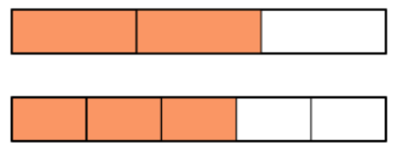  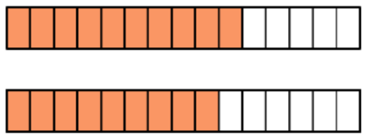  $$\frac{10}{15}$$ | $$\frac{3}{5}$$  $$\frac{9}{15}$$  >
$$\frac{3}{4}$$  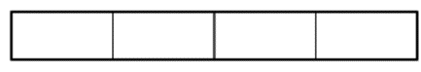  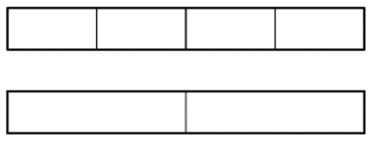  $$\frac{}{4}$$ | $$\frac{1}{2}$$  $$\frac{}{4}$$  $$\frac{3}{4}>\frac{2}{4}$$
$$\frac{2}{3}$$  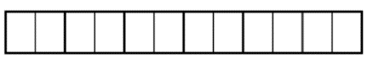  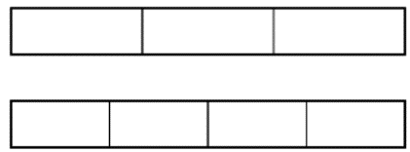  $$\frac{}{12}$$ | $$\frac{3}{4}$$  $$\frac{}{12}$$  $$\frac{8}{12}<\frac{9}{12}$$
$$\frac{2}{3}$$  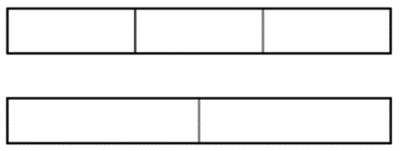  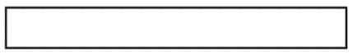 | $$\frac{1}{2}$$  $$\frac{4}{6}>\frac{3}{6}$$
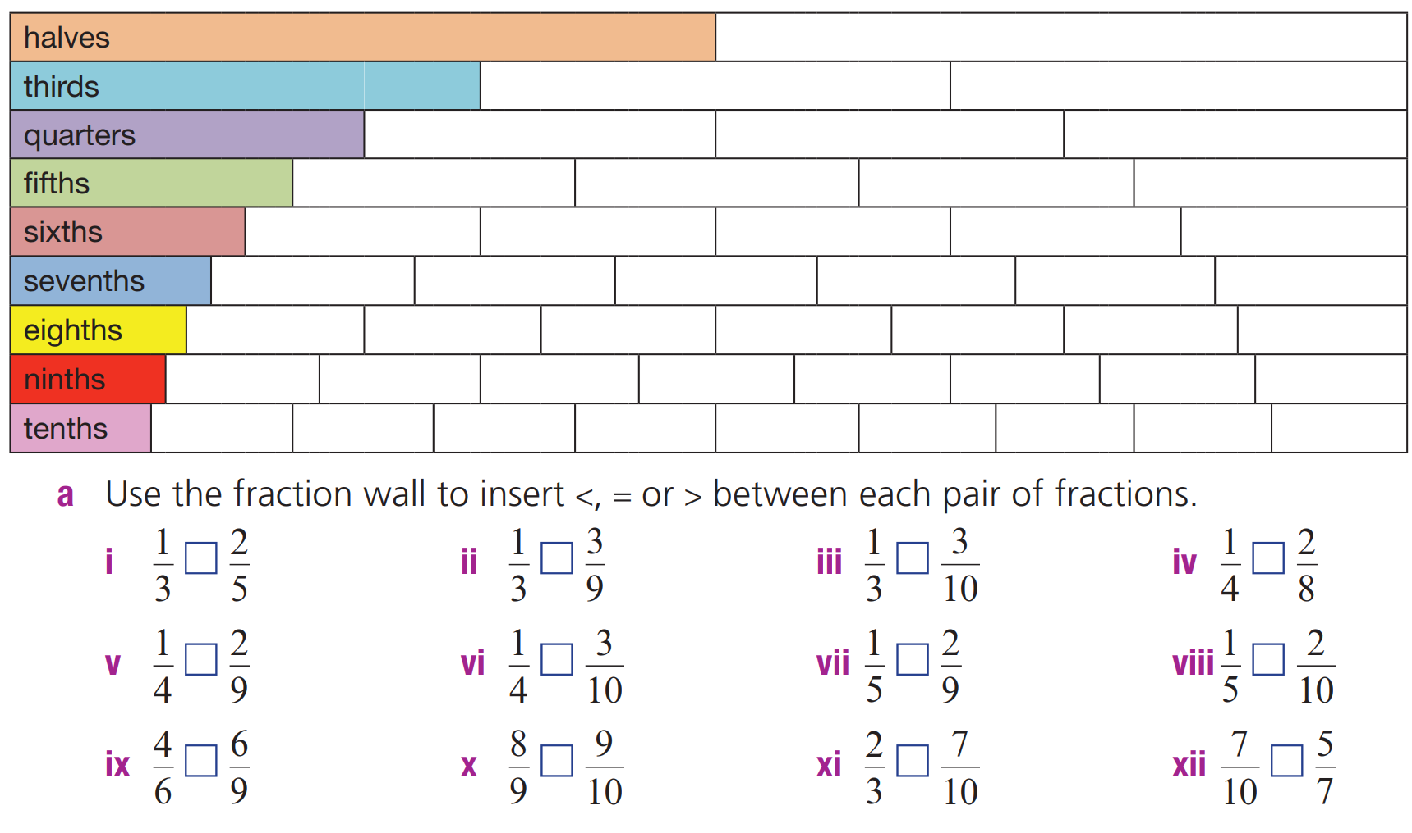
- Use the fraction wall to compare these fractions using relational symbols <, >, and =.

< | = | > | =
> | < | < | =
= | < | < | <

Development
- Compare these fractions by changing them to their lowest common denominator then using <, >, or =
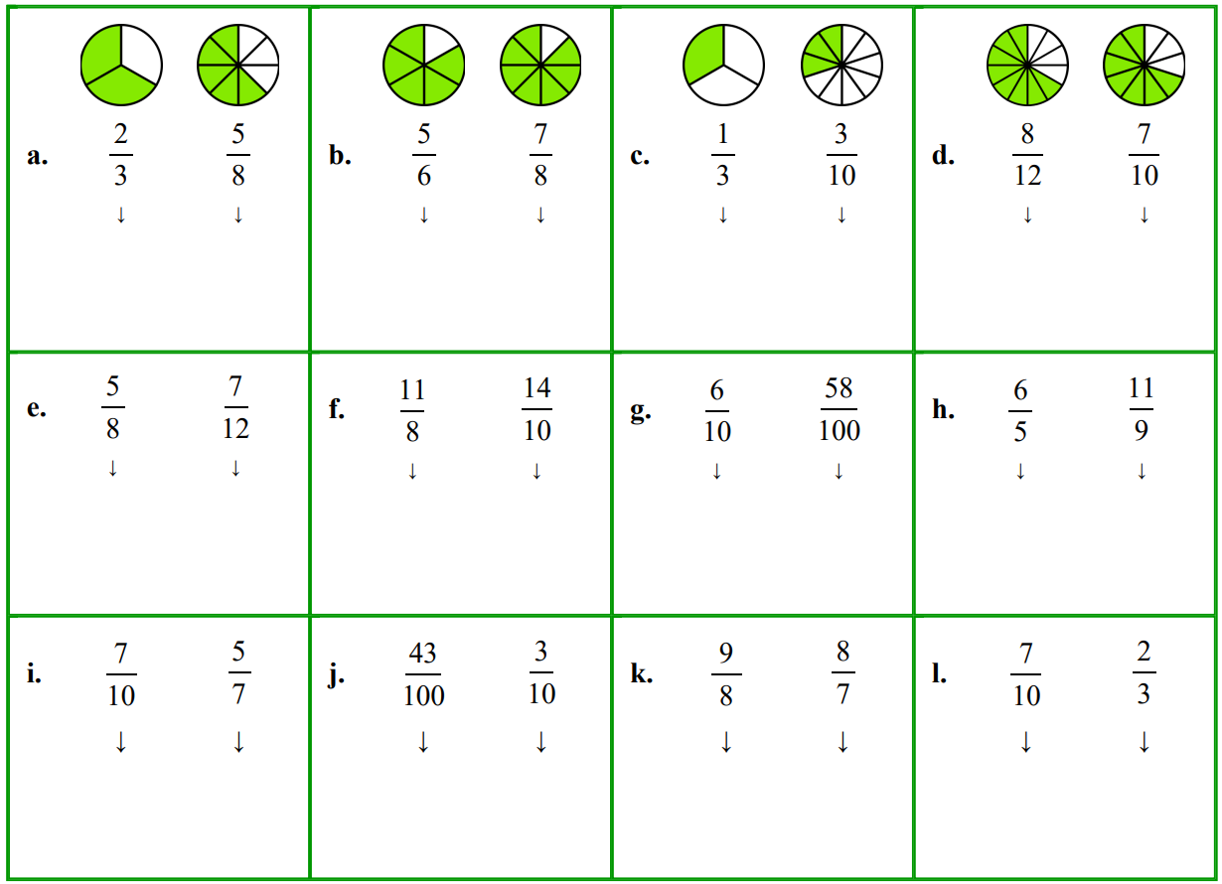  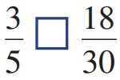  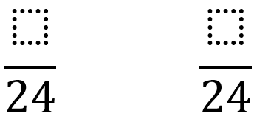  $$\frac{16}{24}>\frac{15}{24}$$ | 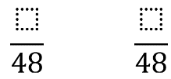  $$\frac{40}{48}<\frac{42}{48}$$ | 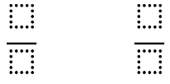  $$\frac{10}{30}>\frac{9}{30}$$
< | $$\frac{4}{5} \frac{3}{4}$$  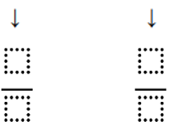  > | $$\frac{5}{3} \frac{3}{2}$$  >
$$\frac{2}{3} \frac{3}{4}$$  < | $$\frac{2}{5} \frac{5}{8}$$  < | $$\frac{6}{8} \frac{4}{6}$$  >
$$\frac{5}{6} \frac{9}{10}$$  < | $$\frac{7}{11} \frac{3}{5}$$  > | $$\frac{12}{5} \frac{19}{8}$$  >
$$\frac{15}{7} \frac{10}{4}$$  < | $$\frac{8}{5} \frac{15}{8}$$  < | $$\frac{5}{3} \frac{12}{7}$$  <

Mastery
- Circle the largest fraction by making their denominators the same
$$\frac{2}{3}$$ | 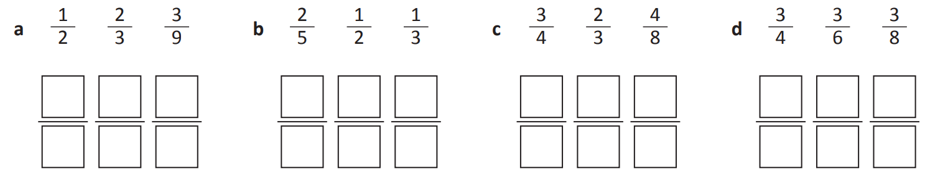  $$\frac{1}{2}$$ | $$\frac{3}{4}$$ | $$\frac{3}{4}$$

- Circle the smallest fraction by making their denominators the same
$$\frac{3}{8}$$ | 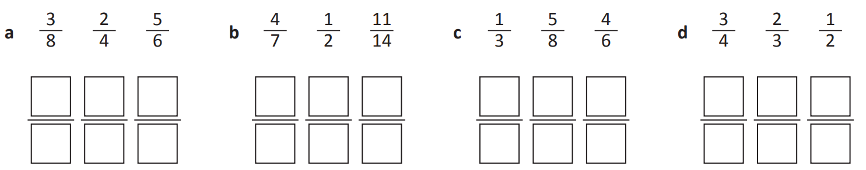  $$\frac{1}{2}$$ | $$\frac{1}{3}$$ | $$\frac{1}{2}$$

- Sam shaded two rectangles and decided $\frac{1}{2}$ is smaller than $\frac{1}{4}$.
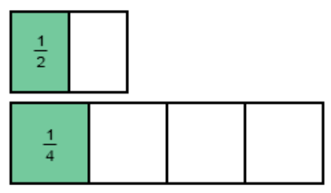
Do you agree? Explain why or why not.

In this case, yes, but only because the whole is different sizes.
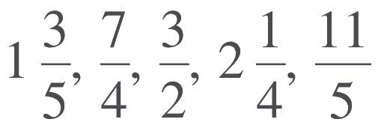
- Arrange these fractions in ascending order by:

  - Expressing as improper fractions: …………………………………
  - Determining the LCD: …………………………………
  - Rewriting fractions with the LCD: …………………………………
  - Ordering the fractions by comparing numerators: …………………………………
  - Rewriting fractions back in their original form. …………………………………
$$\frac{3}{2}, 1\frac{3}{5},\frac{7}{4},\frac{11}{5}, 2\frac{1}{4}$$
- Compare these fractions.
      
    

